Style Guidelines for Final Year Project ReportsMEGILANCE
Final Year Project – Mid Report
Session 2022-2026
A 4th Year Student

A project submitted in partial fulfillment of the requirements for the Degree
of
BSc. (Hons.)BS in Computer Science / Software Engineering / Artificial Intelligence



Department of Computer Science
COMSATS University Islamabad (CUI), Lahore Campus

Project Details
Project ID (for office use)
Type of project |  |  | [ ] Traditional [ ] Industrial [ ] Continuing
Nature of project |  |  | [ ] Development [ ] Research & Development
Sustainable Development Goals(SDGs) |  |  | [ ] Good Health and Well-Being [ ] Quality Education  [ ] Industry, Innovation, and Infrastructure [ ] Gender Equality  [ ] Decent Work and Economic Growth [ ] Climate Action
Area of specialization |  |  | [ ] Artificial Intelligence (AI) [ ] Blockchain [ ] Cybersecurity  [ ] Data Science and Analytics [ ] Game Development  [ ] Internet of Things (IoT) [ ] Natural Language Processing (NLP)  [ ] Mobile App Development [ ] Web Development
Project Group Members
Sr.# | Reg. # | Student Name |  | Email ID | Signature
(i) | FA22-BSE-199 | GHULAM MUJTABA |  | Fa22-bse-199@cuilahore.edu.pk
(ii) | FA22-BSE-153 | MUHAMMD WAQAR UL MULK |  | Fa22-bse-153@cuilahore.edu.pk
Declaration: The candidates confirm that the work submitted is their own and appropriate credit has been given where reference has been made to the work of others.
Plagiarism Free Certificate
This is to certify that, I am ________________________ S/D/o _______________________, group leader of FYP under registration no CUI /_________________/LHR at the Computer Science Department, COMSATS University Islamabad, Lahore Campus. I declare that my FYP proposal is checked by my supervisor and the similarity index is ________% that is less than 20%, an acceptable limit by HEC. The report is attached herewith as Appendix A.
Date: _________ Name of Group Leader: ______________________ Signature: __________

Name of Supervisor: __________________ Co-Supervisor (if any):_________________
Designation: _____________________ Designation: _____________________
Signature: _____________________ Signature: _____________________

HoD: _____________________
Signature: _____________________
ABSTRACT
The global gig economy, while a vital source of economic growth, is fundamentally hindered by systemic issues within centralized platforms, including excessive transaction fees, restricted payment gateway access, and opaque reputation systems. This financial friction and lack of trust disproportionately impact local freelancers, impeding their ability to compete globally and secure fair compensation. To mitigate these issues, the MegiLance project proposes a novel, hybrid decentralized platform that strategically integrates Artificial Intelligence (AI) for enhanced intelligence and Blockchain technology for secure transactions. The primary objectives are to implement a Smart Contract-Based Escrow system to guarantee low-cost, trustless payments and to deploy AI modules for objective freelancer ranking, review sentiment analysis, and price forecasting. Utilizing a modern stack of Next.js, FastAPI, and Solidity, the project is designed to deliver a secure, transparent, and equitable marketplace, with expected outcomes including significantly reduced transaction costs, increased financial security, and a more merit-based system for talent discovery.
Acknowledgement
I really want to say thanks to everyone who helped me during this Final Year Project - without you, it wouldn't have been possible. Big shout-out to my supervisor, Dr Junaid for always giving solid advice, honest feedback, plus pushing me when things got tough; that made a real difference in how this project turned out. The Department of Computer Science at COMSATS University Islamabad, Lahore Campus, gave us what we needed - not just tools but also an atmosphere where learning actually meant something. Shoutout to my team, Muhammad Waqar Ul Mulk and Mujtaba for sticking through every hurdle together we pushed as one unit. And last, massive love to my family and friends for being there nonstop, even when I was buried under work.

Table of Contents
Chapter 1. Introduction 9
1.1 Introduction 9
1.1.1 The Global Gig Economy and Pakistan’s Role 9
1.1.2 Technological Foundation and Rationale 10
1.1.3 The Academic and Career Impact 10
1.2 Problem Statement 10
1.2.1 Financial Inefficiency and High Transaction Costs 10
1.2.2 Market Opacity and Pricing Uncertainty 11
1.3 Proposed Solution 11
1.3.1 Core Solution: Hybrid Architecture 11
1.3.2 AI-Driven Intelligence and Objectivity 11
1.3.3 Technical Implementation 11
1.4 Main Objectives 12
1.4.1 Core Development Objectives 12
1.4.2 Trust and Security Objectives 12
1.4.3 Intelligence and Scalability Objectives 12
1.5 Assumptions & Constraints 12
1.5.1 Assumptions 12
1.5.2 Constraints 13
1.6 Project scope 13
1.6.1 In-Scope Functionality 13
1.6.2 Out of Scope Functionality 13
1.7 Software Development Lifecycle Model 13
1.7.1 Rationale for Agile/Scrum 13
1.7.2 Agile Implementation 14
Chapter 2. Requirement Analysis 15
2.1 Literature Review 15
2.1.1 Review of Freelancing Marketplace Models 15
2.1.2 Review of Blockchain Applications in the Gig Economy 15
2.1.3 Review of Artificial Intelligence in Talent Management 15
2.2 Stakeholders List 16
2.3 Requirements Elicitation 17
2.3.1 Functional Requirements 17
2.3.2 Non-functional Requirements 18
2.3.3 Requirements Traceability Matrix 20
2.4 Use Case Description 20
Chapter 3. System Design 24
3.1 Use Case Design 25
3.2 Activity Diagram 31
3.3 Sequence Diagram 36
3.4 Software Architecture Diagram 41
3.5 Class Diagram 43
3.6 Database Diagram 43
3.7 Collaboration Diagram 44
Chapter 4. System Testing 45
4.1 Test Cases Design 45
4.2 Unit / Integration / Acceptance Testing 49
4.2.1 Unit Testing 49
4.2.2 Integration Testing 49
4.2.3 Acceptance Testing (System and User) 49
Chapter 5. Implementation 49
5.1 Work Breakdown Structure (WBS) 50
5.2 Team Roles and Responsibilities 51
5.3 Tools and Technologies 52
5.4 Implementation Details 53
5.4.1 Core API Implementation (FastAPI) 54
5.4.2 Implementation of the AI Service Stub 54
5.5 Screenshots of Prototype / System 55
5.6 Challenges During Implementation 56
Chapter 6. References 56

List of Tables
Table 1-1 Technical Implementation 11
Table 1-2 Agile Imlementation 14
Table 2-1 Stakeholders List 16
Table 2-2 Authentication and User Management (FR1 - FR10) 17
Table 2-3 Project and Proposal Management (FR06 – FR10) 17
Table 2-4 Contract, Payment, and Review Management (FR11 – FR15) 18
Table 2-5 AI and Intelligence Features (FR16 – FR20) 18
Table 2-6 Performance Requirements (NFR1 - NFR5) 19
Table 2-7 Usability and Maintainability Requirements (NFR6 – NFR14) 19
Table 2-8 Use Case: UC1 - Post a Project 20
Table 2-9 Use Case: UC2 - Submit a Proposal 21
Table 2-10 Use Case: UC3 - Accept Proposal and Initiate Contract 22
Table 2-11 Use Case: UC4 - Submit Work and Approve Payment 22
Table 2-12 Use Case: UC5 - Submit Review and Update Ranking 23
Table 2-13 Use Case: UC6 - Admin User Management 24
Table 4-1 Core Functional Test Cases (TC-001 to TC-015) 46
Table 4-2 AI and Blockchain Test Cases (TC-016 to TC-021) 47
Table 4-3 Non-Functional Test Cases (TC-022 to TC-028) 48
Table 5-1 WBS for MegiLance Project 50
Table 5-2 Team Roles and Responsibilities 51
Table 5-3 Tools and Technologies 53
Table 5-4 Challenges During Implementation 56

List of Figures
Figure 3-1 Use Case Design 25
Figure 3-2 Freelancer Profile Management 25
Figure 3-3 Client Job Posting & Selection 26
Figure 3-4 AI-Powered Ranking & Sentiment 27
Figure 3-5 Dispute Resolution 28
Figure 3-6 Payment & Withdrawal 29
Figure 3-7 Search & Filtering 29
Figure 3-8 Review & Rating Submission 30
Figure 3-9 System Administration/Maintenance 30
Figure 3-10 Activity Diagram 33
Figure 3-11 Project Posting with AI Price Forecast 36
Figure 3-12 Smart Contract Escrow Funding 36
Figure 3-13 Review Submission and AI Sentiment Analysis 37
Figure 3-14 AI Ranking Recalculation (Asynchronous Job) 37
Figure 3-15 Dispute Initiation and Logging 38
Figure 3-16 Admin User Deactivation (Security Focus) 38
Figure 3-17 Project Search and Filtering (Performance Focus) 39
Figure 3-18 Work Approval and Fund Release (Web3 Focus) 39
Figure 3-19 Frontend State Management (Internal Flow) 40
Figure 3-20 Project Moderation (Admin Workflow) 40
Figure 3-21 Software Architecture Diagram 43
Figure 3-22 Class Diagram 43
Figure 3-23 Database Diagram 44
Figure 3-24 Collaboration Diagram 45

Introduction

Introduction
The gig economy around the world has changed how people work, opening new doors for talented individuals to team up with customers across continents. In countries such as Pakistan, this shift hits harder - many young, tech-literate folks are ready to sell their talents abroad. Growth in freelance work there has exploded, bringing in vital foreign cash that boosts the overall economy. Still, progress gets blocked by weak systems inside current online hubs, which points straight to needing a fairer, clearer, and stronger platform built from scratch. While current sites help people connect worldwide, they cost freelancers a lot because of steep fees often between 10% and 20%. On top of that, relying on old-school banks or outside payment helpers slows things down - payments get held up, fees pile up, rules get messy. Especially tough if you're working solo from places where money movement is tightly watched or global pay options are spotty. Then again, big central platforms often keep their rating systems murky; reviews and rankings don’t always reflect real skill, so good workers stay hidden by unfair glitches. That’s exactly why MegiLance exists to hit back at these stubborn issues head-on. It's building a fresh kind of freelance spot, mixing smart automation with blockchain trust, aiming for speed without sacrificing fairness or safety. The central innovation is a hybrid architecture that utilizes the speed and familiarity of modern Web2 technologies (Next.js and FastAPI) for the user interface and core business logic, while deploying the immutable, trustless nature of Web3 (Blockchain) for all critical financial and reputation based transactions. The platform’s core vision is to empower Pakistani freelancers by offering a secure, low cost payment infrastructure via proposed crypto based escrow systems thereby bypassing traditional financial intermediaries and their associated high fees and delays. Simultaneously, the integration of AI is intended to introduce objectivity and intelligence into the marketplace. This includes AI driven candidate scoring to support fair competition, checking customer opinions through mood detection to reduce unfair or skewed ratings, also helping newcomers pick balanced prices via forecasting features. Building MegiLance isn't easy it's a solid test of end-to-end coding skills, covering today’s practical tech setup from top to bottom. It keeps tasks separate where needed: Next.js 16 runs the quick-loading, design-flexible front layer; at the back, FastAPI handles requests fast using async methods. Picks like Turso (libSQL) for shared data storage plus Docker for packaging show real-world thinking toward growth and upkeep, while still acknowledging how far this early version is from a polished, ready-for-market platform. The next parts break down what MegiLance wants to fix, how tech can help, clear goals for the project, also the limits and boundaries shaping how the system gets built. This report covers everything over 100 pages packed with details from broad design ideas down to small coding choices and works as the full school record of a tough engineering job.

The Global Gig Economy and Pakistan’s Role
The global gig economy is forecast to surpass $455 billion, fueled by a growing demand for flexible, specialized labor. Pakistan has established itself as a major participant in this market, with freelance exports contributing hundreds of millions of dollars annually to the national treasury [9]. The nation’s demographic dividend a large, young, and educated populace ideally positions it to capitalize on this trend. Nevertheless, this potential is frequently hampered by infrastructural and systemic obstacles. Financial Friction and Capital Flight: A major obstacle is the excessive cost associated with cross-border payments. Freelancers frequently forfeit a significant percentage of their income to platform commissions, withdrawal charges, and disadvantageous currency conversion rates levied by conventional financial institutions and payment processors . This financial friction not only diminishes the freelancer’s net income but also discourages global market participation. MegiLance seeks to alleviate this by proposing a direct, low-fee payment channel utilizing stablecoins (e.g., USDC), exploiting the efficiency of blockchain technology to reduce transaction costs to a mere fraction of traditional rates.

Technological Foundation and Rationale
The tech behind this project uses today’s standard full stack methods built to scale easily while staying manageable. Picking these tools wasn’t random; it follows what works now in the field, helping the app last longer.
Frontend (Next.js 16 & TypeScript): Picking Next.js 16 with the App Router plus TypeScript builds a solid base for handling many user types like Admins, Clients, or Freelancers. Because it supports SSR along with SSG, pages load fast while boosting search visibility and cutting down time until interaction. Using TypeScript throughout the client side keeps data types in check, slashing bugs that pop up during runtime; this boosts reliability, especially when scaling up.
Backend (FastAPI & Python): The backend runs on FastAPI - a modern Python framework built for speed. Instead of waiting around, it handles many users at once by using async and await, which helps when fetching data from databases or reaching out to outside tools like AI or blockchain systems. It builds API docs automatically, so there's less manual work. Thanks to Pydantic, checking if data is correct happens right away, keeping everything reliable without extra effort.
Database (Turso/libSQL): Picking Turso made sense during the FYP stage it’s based on libSQL, which comes from SQLite. Even though big systems usually go for sharded PostgreSQL, this one uses Turso because it spreads data across locations and deploys fast. It stays online reliably without costing much, fitting well for early testing. Plus, keeping SQL support means swapping to PostgreSQL later could still work smoothly.
Hybrid Architecture: What stands out is the mix of two systems working together. Core tasks like handling users or posting projects run on a quick Web2 setup using FastAPI. On the flip side, things tied to trust - like holding payments, releasing funds, or closing contracts - happen through Web3 smart contracts built with Solidity. Splitting these roles keeps performance smooth and responsive. At the same time, it uses blockchain’s solid protection where it matters most.

The Academic and Career Impact
The MegiLance effort works like a final test, showing how classroom coding ideas can tackle actual problems that matter in business. This write-up counts as solid school work - laying out how a layered tech setup was built from scratch. It covers real hurdles faced when mixing old-style web tools with new blockchain ones. Instead of big teams, it used quick cycles and teamwork checks to stay on track. Choosing Turso instead of classic databases like PostgreSQL means giving up some features for speed and simplicity. A full UML breakdown shows how the marketplace works step by step, making messy flows easier to grasp. Job-wise, this isn't just code - it proves real skill with tools companies want: Next.js, FastAPI, TypeScript, Docker. It’s proof you can build tough systems, set up secure logins, stick with big projects over months. That kind of track record makes you stand out for junior full-stack jobs or focused frontend/backend gigs.

Problem Statement
The freelancing market, particularly for professionals in Pakistan, is characterized by three critical, interconnected problems that MegiLance seeks to address: Financial Inefficiency, Trust Deficit, and Market Opacity.

Financial Inefficiency and High Transaction Costs
Old style payment setups plus online hubs make it tough for freelancers to move money smoothly. High fees hit hard: big sites take 10% to 20% from freelancers this stings more in poorer countries where people earn less anyway. Pakistani freelancers often can't use fast global payment options PayPal isn't an option there, so they fall back on methods like Payoneer or wire transfers, which take longer while charging steep withdrawal costs along with weak exchange rates. Freelancers often wait days to get paid because banks take time to process transactions, this slows down their income flow, shaking up how they manage money day to day.

Market Opacity and Pricing Uncertainty
The lack of clear market data makes it difficult for freelancers, especially new entrants, to price their services competitively and fairly.New freelancers often underprice their work due to a lack of market intelligence, leading to reduced earnings and a “race to the bottom” on price. Clients struggle to efficiently filter and discover the best talent, often relying on basic keyword searches rather than sophisticated, objective metrics of skill and reliability.

Proposed Solution
MegiLance proposes a Hybrid Decentralized Freelancing Hub that directly tackles the problems of financial inefficiency, trust deficit, and market opacity through the strategic integration of AI and Blockchain technologies.

Core Solution: Hybrid Architecture
The sokution isn't just Web3 it's a practical mix that pulls strengths from two sides. Instead, it uses Web2 basics like FastAPI and Next.js to deliver speed, ease, and room to grow when handling profiles, exploring projects, or sending messages. That way everyday actions stay smooth and quick. On top of that there is a Web3 level built with Solidity and blockchain, which handles key money moves and rep-related steps without needing trust. This part keeps everything secure and unchangeable.

AI-Driven Intelligence and Objectivity
The proposed AI module injects objectivity and intelligence into the marketplace: AI-Powered Talent Ranking: A machine learning model is proposed to analyze a freelancer’s entire history skills, project completion rate, communication metrics, and verified reviews to generate an objective, transparent AI Ranking Score. This score is designed to be more reliable than simple star ratings, promoting meritocracy. Review Sentiment Analysis: A Natural Language Processing (NLP) model is proposed to analyze the sentiment of client reviews. This helps the platform flag potentially malicious, retaliatory, or overly biased feedback, ensuring that a freelancer’s reputation is protected from unfair attacks. Price Prediction and Guidance: An AI model is proposed to analyze market data (project type, required skills, freelancer experience) to provide both clients and freelancers with a data-driven Price Forecast Range. This tool helps new freelancers price their services competitively and helps clients budget accurately, reducing market opacity.

Technical Implementation

Table 1-1 Technical Implementation
Tier | Technology | Purpose
Presentation | Next.js 16, TypeScript | Responsive UI, Multi-role portals, Theme System
Application | FastAPI, Python | REST API, Business Logic, Auth, Pydantic Validation
Data | Turso (libSQL) | Core data storage (Users, Projects, Reviews)
Trust/Finance | Solidity, Ethereum  Testnet | Proposed Smart Contract Escrow and Payment Logic
Intelligence | Python (Stub) | Proposed AI/ML Service Endpoints (Ranking, Sentiment)

Main Objectives
The primary goal of the MegiLance project is to design, develop, and document a robust, full-stack freelancing platform prototype. The objectives are categorized into Core Development, Trust & Security, and Intelligence & Scalability.
- Core Development
- Trust and Security Objectives
- Intelligence and Scalability Objectives

Core Development Objectives
Build a full web app with different user types like admin, client, freelancer using Next.js 16 alongside TypeScript. Build a fast backend that works through APIs, using FastAPI to handle create, read, update, delete actions on main items like Projects, Proposals, Reviews.Build a safe login setup with roles - using JWT plus bcrypt to protect passwords. Pick tools that keep access tight while letting users do only what they’re allowed. Set permissions by role so no one gets extra control by mistake.Set up a neat database layout that’s easy to keep tidy using SQLAlchemy along with Turso (which runs on libSQL) to handle every main feature of the app.

Trust and Security Objectives
Design the architecture for a Smart Contract Escrow System using Solidity, defining the logic for fund locking, release, and dispute handling. (Conceptual/Design Phase). Set up required API routes using Fastapi so it works with the web3 part like starting smart contract uploads or sending out funds when needed. Make sure the app stays safe from typical web threats like SQL Injection or XSS by using ORMs along with Pydantic checks.

Intelligence and Scalability Objectives
Build a small AI service using Python it’ll take in data then shoot back smart answers like ranking or mood scores. Build a full system layout using required UML models like Use Case, Activity, Sequence, Class, ERD, along with Collaboration to show how the system works and what it's made of.Write out a clear testing strategy for the system cover at least thirty tests, both feature based and performance checks, targeting key marketplace functions using real-world scenarios instead of theory.

Assumptions & Constraints
The development of MegiLance was governed by a set of critical assumptions and constraints that shaped the final delivered prototype.

Assumptions
A1. User Technical Literacy: It is assumed that users (both clients and freelancers) possess a basic level of technical literacy required to interact with a modern web application and, specifically, a crypto wallet interface (e.g., MetaMask). A2. External Service Availability: It is assumed that the proposed external services (e.g., a stablecoin payment API like Circle, and a deployed Ethereum testnet for the Smart Contract) are available and functional for integration in a production environment. A3. AI Model Data: It is assumed that sufficient, labeled training data for the AI Ranking and Sentiment models can be acquired or generated post-FYP to train and deploy the full-fledged services. A4. Turso Scalability: It is assumed that the Turso database is sufficiently scalable for the prototype and initial launch phase, deferring the need for a complex PostgreSQL cluster setup.

Constraints
C1. Time Constraint: The project was constrained by the academic timeline of the Final Year Project (15 months), which necessitated prioritizing the core Web2 marketplace over the full implementation of the AI and Blockchain features. C2. Resource Constraint (Financial): The project operated under a minimal budget, precluding the use of expensive cloud services (e.g., AWS Lambda, dedicated ML instances) and requiring the use of cost-effective solutions (e.g., Turso, Docker Compose for local development). C3. Scope Constraint (AI/Blockchain): Due to the complexity and time constraint (C1), the AI and Blockchain modules were limited to the Architectural Design and API Stub phase, rather than full implementation. C4. Team Size Constraint: The project was developed by a small team, limiting the parallel development capacity and requiring a focus on essential features over advanced functionalities like real-time chat or video conferencing.

Project scope
The scope of MegiLance is strictly defined to ensure the successful delivery of a high-quality, functional prototype that meets the FYP-I criteria.

In-Scope Functionality
Sign up, set up your account, post jobs freelancers send offers while clients leave feedback after works done. Profiles stay updated anytime through personal dashboards. Logins use secure tokens plus user roles decide what you can see. A smooth layout that fits any screen size, adjusts to light or dark preferences crafted using Next.js 16. A full REST-style interface made using FastAPI, handling every main part of the system. System Design: Full UML diagrams plus structure plans covering every part, along with early ideas for AI and blockchain sections. Creating check steps for features plus how they work together, laying out tests for code units, linking parts, also final approval checks.

Out of Scope Functionality
Build real AI models from start to finish train them, then put them to work spotting emotions, sorting results, or guessing prices. Instead of just testing ideas, this step brings working tools live using machine learning that teaches patterns and makes smart guesses based on data. Use real blockchain: put the smart contract on a live network. Also connect it to an active crypto payment system like Circle’s API for actual transactions. Real Time Communication: Implementation of WebSocket based real time chat. Full CI/CD setup, solid tracking tools, also self-adjusting cloud runs though only Docker Compose works locally. Building a native app though only responsive web design will be used instead.

Software Development Lifecycle Model
The MegiLance project adopted the Agile/Scrum methodology for its Software Development Life Cycle (SDLC). This choice was motivated by the project’s complex and evolving requirements, the need for rapid prototyping, and the small team size.

Rationale for Agile/Scrum
Flexibility: At first, the plan included big ideas like AI or Blockchain - stuff that could shift if it turned out too tough to build fast. With an agile approach, we adjusted what made sense while still hitting the main goal. Rapid Feedback: Since Scrum works in loops, the crew built key marketplace tools early, got opinions from within, then kept improving how the interface felt and how the backend talked to systems using what they learned each round.

Agile Implementation
The project was managed through a series of short, two-week sprints, each culminating in a working increment of the software.
Table 1-2 Agile Imlementation
Phase | Duration | Key Activities
Sprint 1 (Planning) | 4 Weeks | Requirements Elicitation, Tech Stack Finalization, Database Schema Design, UI/UX Mockups.
Sprint 2-3 (Foundation) | 4 Weeks | Backend API Setup (FastAPI), Authentication Module (JWT), Frontend Scaffolding (Next.js).
Sprint 4-6 (Core Marketplace) | 6 Weeks | Project CRUD, Proposal Submission, Review System, Role-Based Access Control.
Sprint 7-8 (Advanced Design) | 4 Weeks | Smart Contract Design ,AI Service API Stub, Comprehensive UML Modeling.
Sprint 9-10 (Testing & Documentation) | 4 Weeks | System Testing, Bug Fixing, Finalizing Technical Documentation and Report Writing.

Requirement Analysis

Literature Review
The growth of MegiLance ties together freelancing platforms, blockchain, yet artificial intelligence. Looking into current research along with market trends helps prove the issue exists. It also supports why this solution makes sense. Plus, it shows how MegiLace brings something new to the table.

Review of Freelancing Marketplace Models
The current global freelancing market is dominated by centralized platforms such as Upwork, Fiverr, and Toptal. These platforms operate on a traditional intermediary model, providing a matching service in exchange for substantial commission fees (typically 10-20%). Upwork and the Open Marketplace Model: Upwork represents the open bidding model, characterized by a vast talent pool and a wide range of projects. While offering scale, this model often leads to a “race to the bottom” on pricing, where quality is sacrificed for cost. Its escrow system, while functional, is centralized, meaning the platform holds the ultimate authority over funds and disputes, a key point of friction for users concerned about transparency and fairness. Fiverr and the Gig-Based Model: Fiverr popularized the fixed price “gig” model, focusing on speed and simplicity. This model, however, struggles with quality control and complex, long-term projects. Both Upwork and Fiverr rely on proprietary, opaque algorithms for talent ranking and dispute resolution, contributing to the trust deficit identified in the problem statement. Toptal and the Vetted Talent Model: Toptal focuses on the top 3% of talent, offering high quality, high-cost services to enterprise clients. This model addresses the quality control issue but excludes much of the global freelance workforce, particularly those in emerging markets.

Review of Blockchain Applications in the Gig Economy
Blockchain can fix trust problems and money hassles in the gig world. Its main ideas - like unchangeable records, no central control, or automated agreements actually work well here. A smart contract handles payments like an escrow - no middleman needed. Thanks to work on DAOs and DeFi, we know this tech works. It runs on code written in Solidity. When the client approves, money moves right away. Rules are set ahead of time. Once met, the system acts instantly. No waiting around for someone to approve manually. The process just happens by itself This cuts out the middleman, so there's no one weak spot or sky-high costs from central control. A few researchers suggest blockchains could store job records securely. When tasks finish, those updates get saved permanently on the network so no one can erase them later. This log shows clear proof of past work without risk of manipulation. Because it’s open and hard to alter, people might rely on it more than current methods when deciding whom to hire. Crypto payments bring faster transfers across borders using coins like USDC, cutting both cost and waiting time. Thanks to blockchain’s quick pace, money moves worldwide in just minutes with tiny fees. This smooth flow tackles payment delays that often-hit freelance workers in Pakistan.

Review of Artificial Intelligence in Talent Management
AI and Machine Learning (ML) are increasingly used to enhance the efficiency and objectivity of talent marketplaces. ML algorithms are widely used by platforms like LinkedIn and Upwork to match job postings with candidate profiles. These models typically analyze keywords, skill tags, and historical success rates. However, the proprietary nature of these algorithms often leads to concerns about bias and opacity. MegiLance proposes an AI Ranking Model that, while proprietary, is designed to be transparent in its input features (e.g., verifiable contract completion, sentiment score) to promote meritocracy. Sentiment Analysis for Reviews: Natural Language Processing (NLP) models, particularly those based on transformer architectures, are highly effective at analyzing the sentiment of text. Applying sentiment analysis to client reviews can provide an objective, quantifiable measure of the emotional tone, helping to filter out malicious or emotionally charged feedback that might unfairly damage a freelancer’s reputation. Price Prediction and Market Intelligence: Regression models can be trained on historical project data (budget, duration, skills required) to predict a fair market price range for new projects. This tool is invaluable for new freelancers who lack the experience to price their services correctly, thereby combating market opacity and the “race to the bottom” phenomenon.

Stakeholders List
The MegiLance project involves several key stakeholders, each with distinct interests, requirements, and levels of influence.
Table 2-1 Stakeholders List
Stakeholder | Role in Project | Key Interests
Freelancers | Primary Users | Earning potential, low fees, secure payments, fair ranking, dispute resolution.
Clients | Primary Users | Quality talent, quick matching, project completion, secure funding, transparent reviews.
Platform Administrators | System Operators | System stability, user moderation, data analytics, revenue generation (future)
FYP Supervisor/Committee | Project Evaluators | Academic rigor, technical  complexity, documentation quality, project completion.
Blockchain Network | External System | Transaction throughput, network stability, smart contract security.
AI Service Providers | External System | API uptime, model accuracy, data privacy.
Future Investors | Business Stakeholders | Market viability, scalability, revenue model, competitive advantage.

Requirements Elicitation
The system requirements are categorized into Functional Requirements (FRs) and Non Functional Requirements (NFRs). The requirements are derived from the problem statement, proposed solution, and the analysis of the existing marketplace models

Functional Requirements
The functional requirements define the specific actions the system must perform. The requirements are detailed to meet the high-volume requirement of the new instructions.
Table 2-2 Authentication and User Management (FR1 - FR10)
ID | Requirement Description | Priority
FR1 | The system shall allow a user to register as either a Client or a Freelancer. | High
FR2 | The system shall enforce strong password policies (min 8 chars, mixed case, number, symbol). | High
FR3 | The system shall use JWT (JSON Web Tokens) for stateless authentication and session management. | High
FR4 | The system shall provide separate dashboards for Admin, Client, and Freelancer roles. | High
FR5 | The system shall allow the Admin to view, edit, and deactivate any user account. | High

Table 2-3 Project and Proposal Management (FR06 – FR10)
ID | Requirement Description | Priority
FR6 | The system shall allow a Client to post a new project, specifying title, description, budget, and required skills. | High
FR7 | The system shall allow Freelancers to browse and search for projects based on keywords, budget, and skills. | High
FR8 | The system shall allow a Freelancer to submit a proposal for an open project, including a bid amount and cover letter. | High
FR9 | The system shall allow the Client to view all proposals submitted for their project. | High
FR10 | The system shall notify the Freelancer when their proposal is accepted or rejected. | High
Table 2-4 Contract, Payment, and Review Management (FR11 – FR15)
ID | Requirement Description | Priority
FR11 | The system shall initiate a Smart Contract upon proposal acceptance (conceptual). | High
FR12 | The system shall require the Client to fund the Smart Contract Escrow before the project starts (conceptual). | High
FR13 | The system shall allow the Freelancer to submit final work deliverables. | High
FR14 | The system shall allow the Client to approve the submitted work. | High
FR15 | The system shall trigger the Smart Contract to release funds to the Freelancer upon Client approval (conceptual). | High

Table 2-5 AI and Intelligence Features (FR16 – FR20)
ID | Requirement Description | Priority
FR16 | The system shall call the AI Service to calculate a new AI Ranking Score for a Freelancer after every complete project (conceptual). | High
FR17 | The system shall call the AI Service to provide a Price Forecast Range when a Client posts a project (conceptual). | High
FR18 | The system shall store the Sentiment Score returned by the AI Service alongside the written review. | High
FR19 | The system shall allow the admin to view the raw sentiment score for moderation purposes. | Medium
FR20 | The system shall allow the Client to filter Freelancers based on their AI Ranking Score. | High

Non-functional Requirements
The non-functional requirements define the quality attributes of the system. The requirements are detailed to meet the high-volume requirement of the new instructions.
Table 2-6 Performance Requirements (NFR1 - NFR5)
ID | Requirement Description | Priority | Type
NFR1 | The system shall load the main dashboard page within 3 seconds under normal load (50 concurrent users). | High | Speed
NFR2 | The system shall process all API requests (excluding AI/Blockchain calls) with a latency of less than 200 milliseconds at the 95th percentile. | High | Response  Time
NFR3 | The system shall support a minimum of 100 concurrent users without performance degradation. | Medium | Scalability
NFR4 | The system shall complete the user login process within 1 second. | High | Speed
NFR5 | The system shall validate all incoming data using Pydantic schemas to prevent malformed requests. | High | Integrity

Table 2-7 Usability and Maintainability Requirements (NFR6 – NFR14)
ID | Requirement Description | Priority | Type
NFR6 | The system shall provide a consistent and intuitive User Interface (UI) across all platforms (desktop, mobile). | High | Usability
NFR7 | The system shall provide a Light and Dark Theme option for user preference. | High | Usability
NFR8 | The system shall provide clear and informative error messages to the user. | High | Usability
NFR9 | The system shall be developed using a modular architecture to facilitate future feature additions and maintenance. | High | Maintainability
NFR10 | The system shall be fully containerized using Docker to ensure consistent deployment across environments. | High | Portability
NFR11 | The system shall be developed using TypeScript to enhance code quality and maintainability. | High | Maintainability
NFR12 | The system shall provide a comprehensive README and setup guide for new developers. | High | Maintainability
NFR13 | The system shall provide a clear visual indicator of the current project status (e.g., Open, In Progress, Complete). | High | Usability
NFR14 | The system shall use a consistent naming convention for all variables, functions, and database fields. | High | Maintainability

Requirements Traceability Matrix

Use Case Description
Use case outline shows what a person does when using a system to reach a certain aim. Usually, it lists the scenario title, who’s involved, setup conditions things that need to already be in place - the primary sequence of actions, side paths if events shift course, and final results after finishing. These outlines make system behavior easier to grasp by focusing on real user needs instead of technical jargon while making sure everyone sees how actual users will experience the features.
Table 2-8 Use Case: UC1 - Post a Project
Attribute | Description
Use Case ID | UC1
Use Case Name | Post a Project
Primary Actor | Client
Goal | To successfully list a new project on the marketplace for Freelancers to bid on.
Preconditions | The Client must be registered and logged into the system.
Postconditions | A new Project record is created in the database with status “Open.” The AI Service is triggered for price forecas
Trigger | Client clicks the “Post New Project” button on their dashboard.

Table 2-9 Use Case: UC2 - Submit a Proposal
Attribute | Description
Use Case ID | UC2
Use Case Name | Submit a Proposal
Primary Actor | Freelancer
Goal | To submit a formal bid to a Client for an open project.
Preconditions | The Freelancer must be registered and logged in. The Project must have a status of “Open.”
Postconditions | A new Proposal record is created in the database, linked to the Project and Freelancer.
Trigger | Freelancer clicks the “Submit Proposal” button on a Project details page.
Normal Flow | 1. Freelancer views the Project details page. 2. Freelancer clicks “Submit Proposal.” 3. System displays the proposal form (Bid Amount, Cover Letter). 4. Freelancer enters the bid amount and writes the cover letter. 5. System sends the proposal data to the FastAPI backend. 6. Backend validates the data. 7. Backend saves the Proposal record to the database with status  “Pending.” 8. System notifies the Client that a new proposal has been submitted. 9. System displays a confirmation message to the Freelancer.
Alternative Flow (A1: Project  Closed) | 2a. If the Project status is not “Open.” 3a. System displays an error: “This project is no longer accepting proposals.”
Alternative Flow (A2: Already  Submitted) | 5b. If the Freelancer has already submitted a proposal for this project. 6b. System returns an error: “You have already submitted a proposal for this project.”

Table 2-10 Use Case: UC3 - Accept Proposal and Initiate Contract
Attribute | Description
Use Case ID | UC3
Use Case Name | Accept Proposal and Initiate Contract
Primary Actor | Client
Goal | To select a Freelancer, accept their proposal, and initiate the secure Smart Contract Escrow process.
Preconditions | The Client must have an open Project with at least one Proposal.
Postconditions | The selected Proposal status changes to “Accepted.” The Project status changes to “Awaiting Funding.” A new Smart Contract is initiated (conceptual).
Trigger | Client clicks the “Accept” button on a specific Proposal.
Normal Flow | 1. Client views the list of Proposals for their Project. 2. Client selects a Proposal and clicks “Accept.” 3. System prompts the Client to confirm the acceptance and the funding amount. 4. Client confirms. 5. Backend updates the Proposal status to “Accepted” and the Project status to “Awaiting Funding.” 6. Backend calls the Web3 Service to deploy a new Smart Contract with the agreed-upon amount and terms (conceptual). 7. System notifies the selected Freelancer that their proposal has been accepted. 8. System redirects the Client to the funding interface.

Table 2-11 Use Case: UC4 - Submit Work and Approve Payment
Attribute | Description
Use Case ID | UC4
Use Case Name | Submit Work and Approve Payment
Primary Actor | Freelancer, Client
Goal | To complete the project cycle by submitting work and releasing the escrowed funds.
Preconditions | The Project status must be “In Progress.” The Smart Contract must be funded.
Postconditions | The Project status changes to “Complete.” Funds are released from the Smart Contract to Freelancer. A Review is enabled.
Trigger | Freelancer clicks “Submit Final Work.”
Normal Flow | 1.Freelancer clicks “Submit Final Work” and uploads deliverables (conceptual). 2. System changes Project status to “Awaiting Approval.” 3. System notifies the Client. 4. Client reviews the work and clicks “Approve Work.” 5. Backend triggers the Web3 Service to call the releaseFunds() function on the Smart Contract (conceptual). 6. The Smart Contract executes, transferring funds to the Freelancer’s wallet. 7. Backend updates Project status to “Complete.” 8. Backend records the contract completion on the blockchain (conceptual). 9. System enables the Client to submit a Review (UC5).

Table 2-12 Use Case: UC5 - Submit Review and Update Ranking
Attribute | Description
Use Case ID | UC5
Use Case Name | Submit Review and Update Ranking
Primary Actor | Client
Goal | To provide feedback on the Freelancer and trigger the AI-powered reputation update.
Preconditions | The Project status must be “Complete.” The Client must not have submitted a review yet.
Postconditions | A new Review record is created. The Freelancer’s AI Ranking Score is updated.
Trigger | Client clicks the “Leave Review” button on the completed Project page.
Normal Flow | 1. Client enters a rating (1-5 stars) and a written comment. 2. System sends the review data to the FastAPI backend. 3. Backend validates the data. 4. Backend calls the AI Service to perform Sentiment Analysis on the written comment. 5.Backend saves the Review record, including the Sentiment Score, to the database. 6. Backend calls the AI Service again to trigger the Freelancer’s AI Ranking Score recalculation. 7. System updates the Freelancer’s profile with the new average rating and AI Ranking Score. 8. System displays a confirmation message.

Table 2-13 Use Case: UC6 - Admin User Management
Attribute | Description
Use Case ID | UC6
Use Case Name | Admin User Management
Primary Actor | Admin
Goal | To maintain the integrity of the platform by managing user accounts.
Preconditions | The admin must be logged in.
Postconditions | A User record is modified (e.g., deactivated, role changed).
Trigger | Admin navigates to the User Management dashboard.
Normal Flow | 1. Admin searches for a specific user (by email or ID). 2. System displays the user’s profile details. 3. Admin selects an action (e.g., “Deactivate Account,” “Change Role”). 4. System prompts for confirmation. 5. Backend executes the action and updates the User record in the database. 6. System logs the action in the audit log (conceptual). 7. System displays a success message.

System Design
The System Design phase translates the functional and non-functional requirements into a concrete blueprint for the MegiLance platform. This chapter details the architectural choices, the structural composition of the system (Class and Database design), and the behavioral aspects (Activity and Sequence diagrams) that govern the system’s operation. The design adheres to the principles of modularity, scalability, and separation of concerns, crucial for a complex hybrid Web2/Web3 application.

Use Case Design
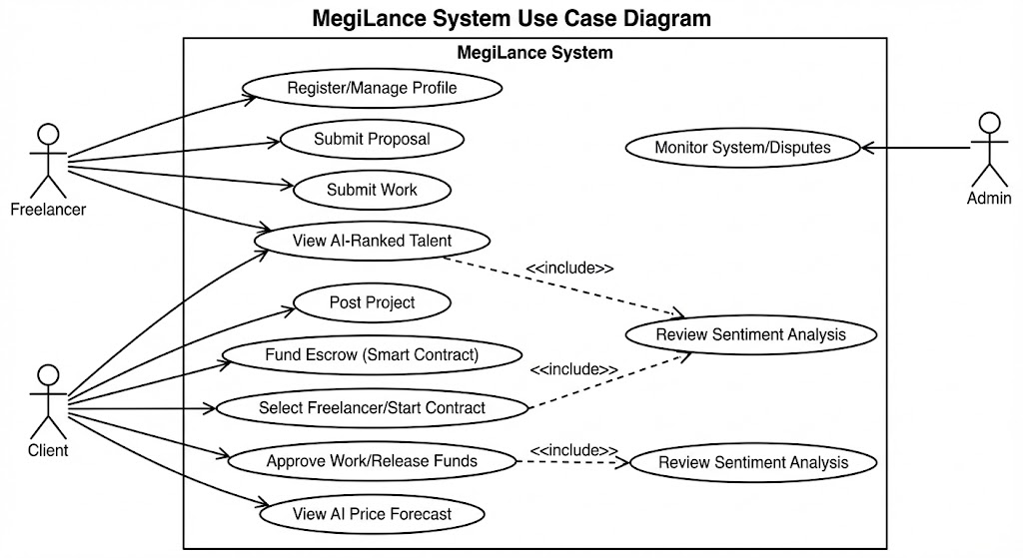
Figure 3-1 Use Case Design
The primary actors are the Client, Freelancer, and Admin. The diagram shows the fundamental interactions: Client posts projects, approves work, and submits reviews. Freelancer manages profiles, submits proposals, and submits work. The diagram also highlights the inclusion of the AI Price Forecast within the project posting process and the Smart Contract Escrow within the work approval process, demonstrating the tight integration of the specialized modules into the core workflow.

Freelancer Profile Management
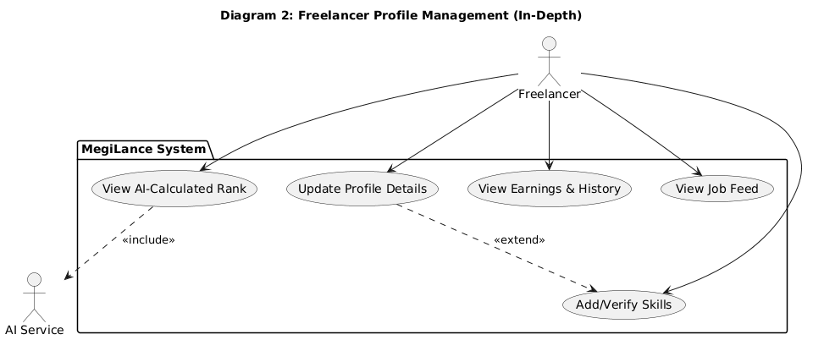
Figure 3-2 Freelancer Profile Management
Figure 3-2 setup dives into what freelancers can do. So they start by setting up an account. After that, updating their profile comes next. They’re also able to verify skills whenever needed. Instead of guessing, they see how the AI ranks them - clear and open. Their past earnings? Yeah, those are trackable too. The whole thing puts trust front and center. No hidden tricks - just real data shaping their standing.

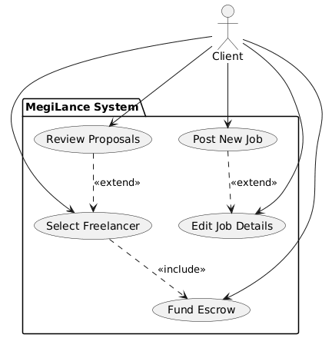
Figure 3-3 Client Job Posting & Selection
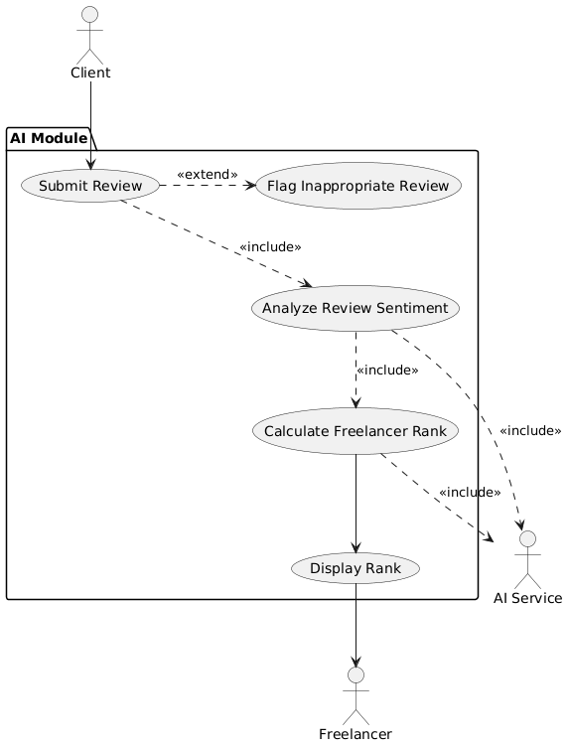
Figure 3-4 AI-Powered Ranking & Sentiment
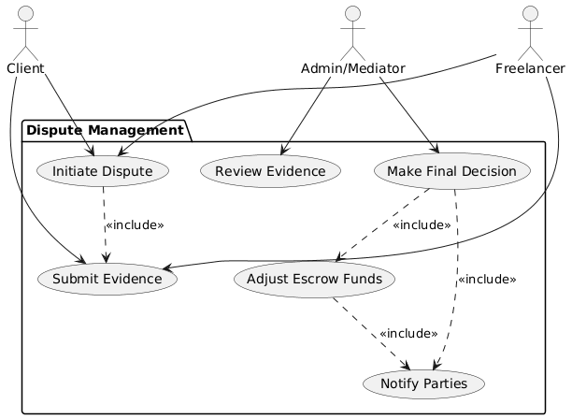
Figure 3-5 Dispute Resolution
Figure 3-6 shows how conflicts between the Client and Freelancer are managed step by step. Instead of just two sides arguing, an Admin or Mediator jumps in to help sort things out. Once someone starts a dispute, actions follow one after another no skipping ahead. After decisions are made, money held in escrow gets updated automatically. Because everything runs on blockchain, changes can't be reversed or altered later. Trust isn't needed since outcomes are locked in through code.
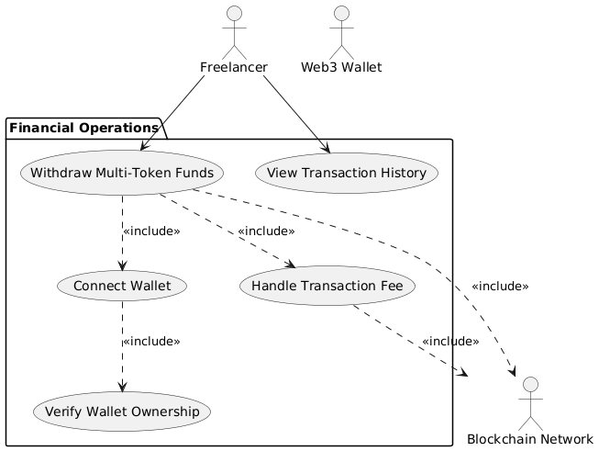
Figure 3-6 Payment & Withdrawal
Figure 3-7 shows how money moves in MegiLance, zeroing in on what freelancers can do to handle and pull out their pay. Instead it splits apart the app’s built-in wallet functions from its link to the Blockchain Network when taking out crypto like USDT or ETH. You’ll notice it leans heavily on Web3 wallets - think Metamask or Trust - to let users tap into funds safely without a middleman. That setup backs up a cheaper, clearer way to move cash through the platform.
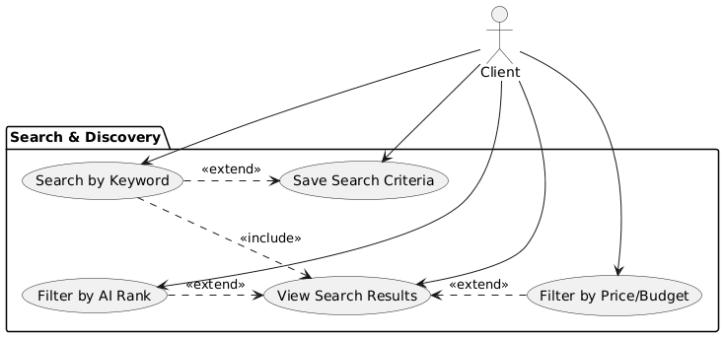
Figure 3-7 Search & Filtering
Figure 3-8 breaks down how the platform handles smart searches. While clients look for gigs, freelancers hunt for work each side uses similar tools. The setup supports narrowing results using basic filters like keyword or cost - but also taps into a special AI Rank score. Instead of guesswork, matches rely on data-powered signals. In short, it’s about getting better fits without extra effort.

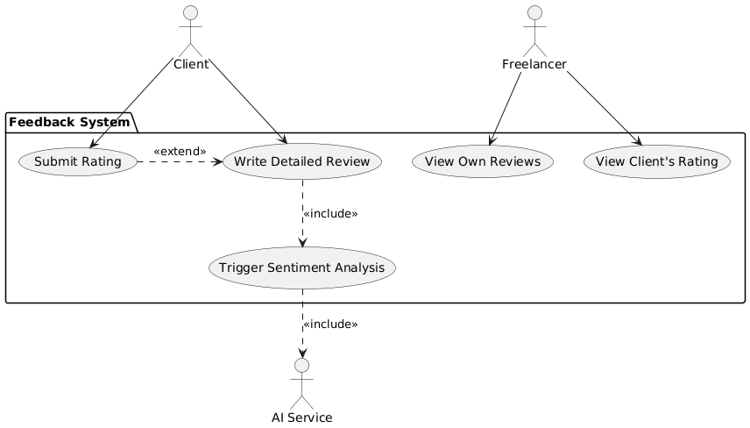
Figure 3-8 Review & Rating Submission

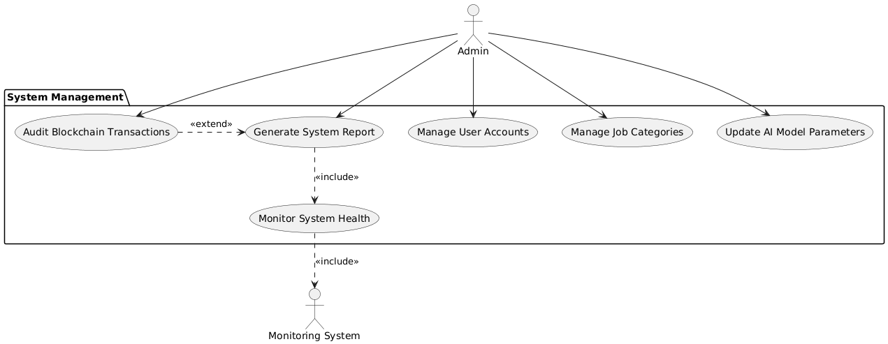
Figure 3-9 System Administration/Maintenance

Activity Diagram
Activity diagrams model the flow of control and the sequence of actions in a system’s process. Given the multi-step nature of a freelancing contract (from posting to payment), multiple detailed activity diagrams are required to capture the full complexity of the system’s behavior, especially the handoffs between the Web2 backend and the Web3/AI services.
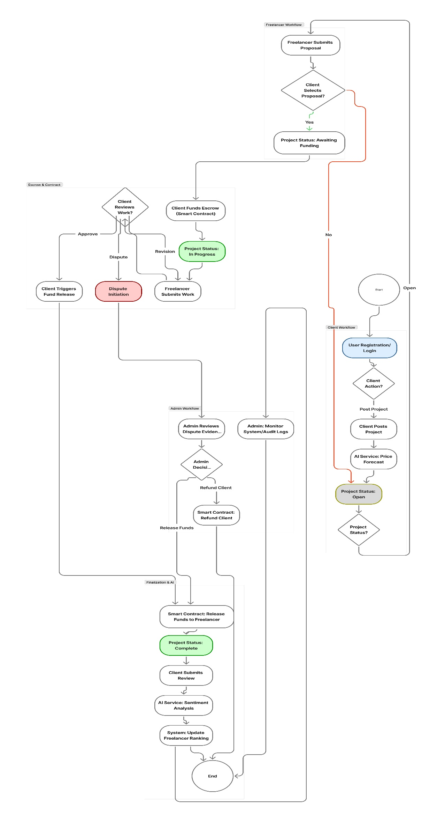
Figure 3-10 Activity Diagram

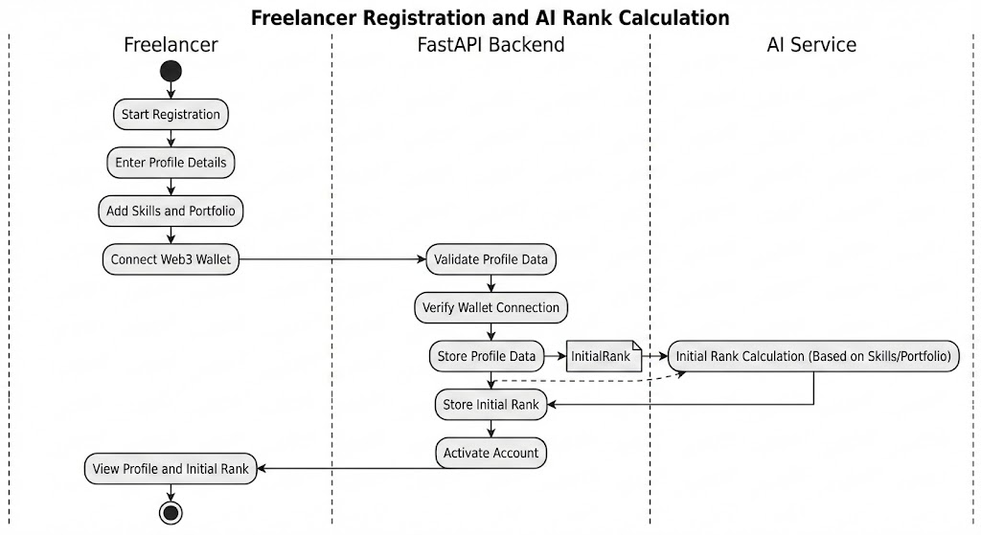
Figure 3-11 Freelancer Registration and AI Rank Calculation

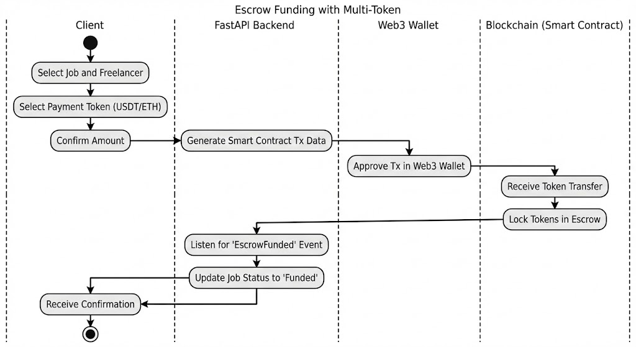
Figure 3-12 Fund Funding with Multi-Token

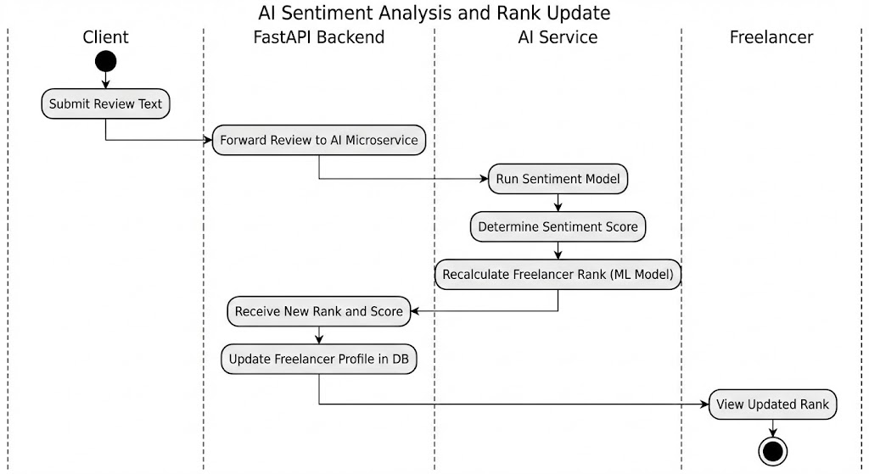
Figure 3-13 AI Sentiment Analysis and Rank Update

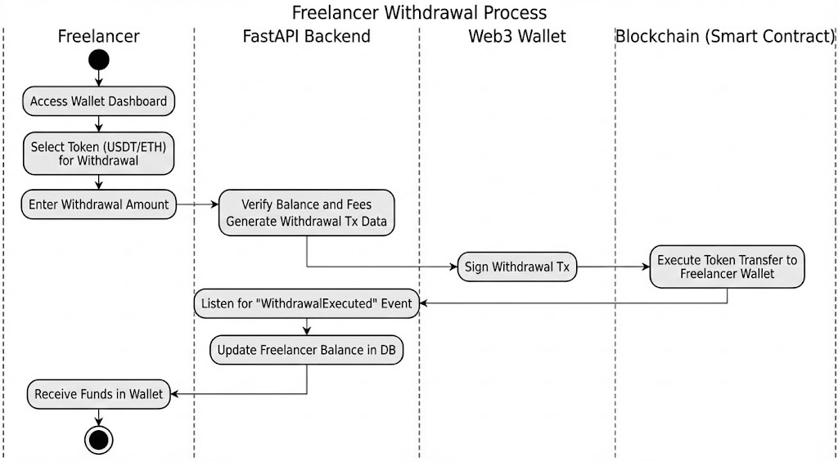
Figure 3-14 Freeelancer Withdrawa; Process

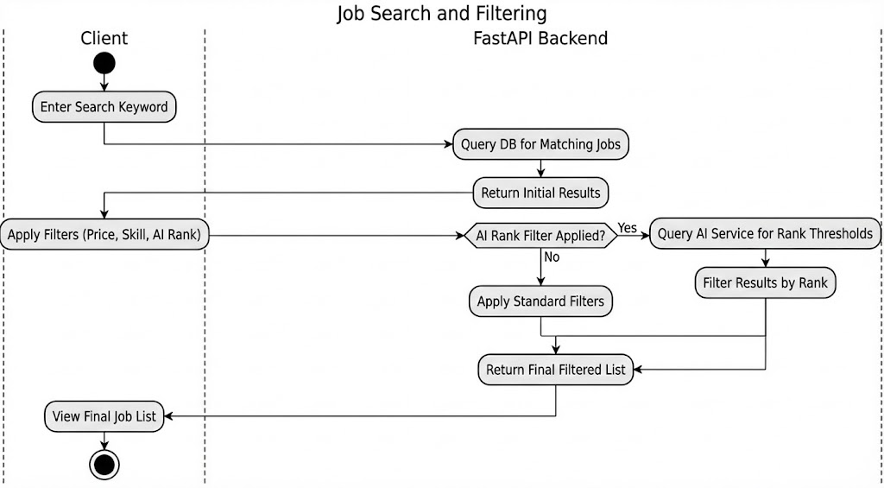
Figure 3-15 Job search and Filtering

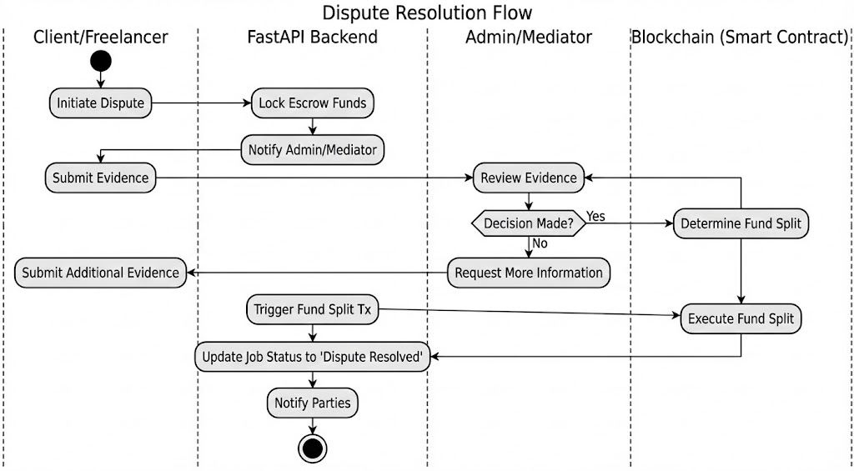
Figure 3-16 Disputer Resolution Flow

Sequence Diagram
Sequence diagrams illustrate the order of messages passed between objects in a specific use case. The MegiLance system requires detailed sequence diagrams to show communication across the three main tiers: Frontend, Backend, and External Services (AI/Web3).
Project Posting with AI Price Forecast

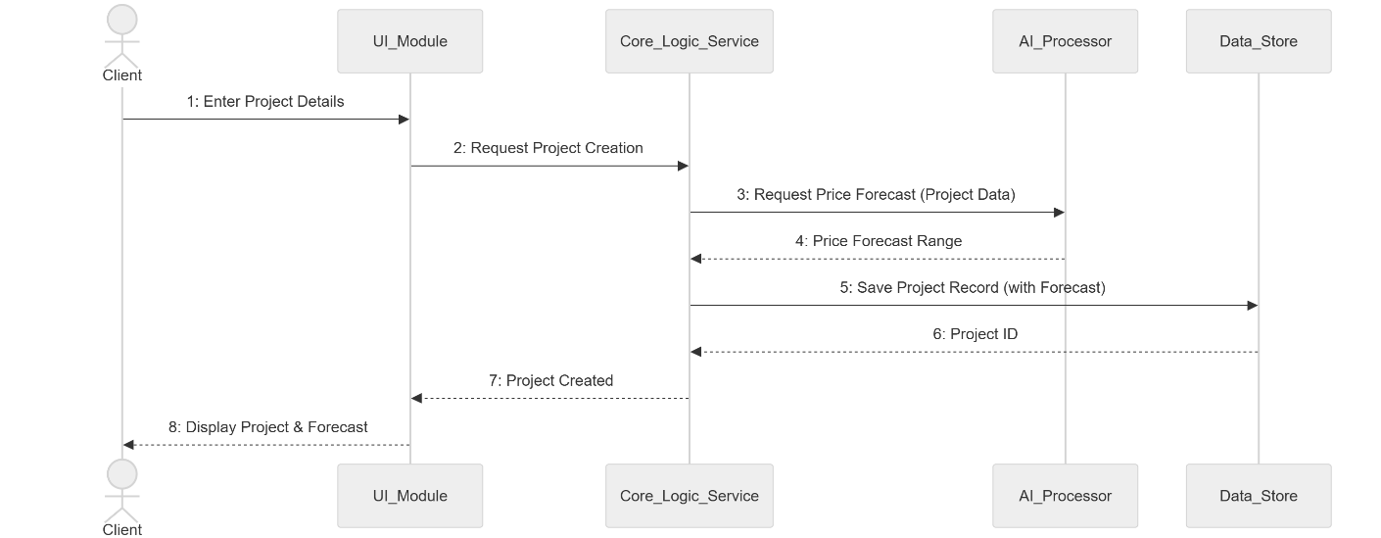
Figure 3-17 Project Posting with AI Price Forecast

Smart Contract Escrow Funding

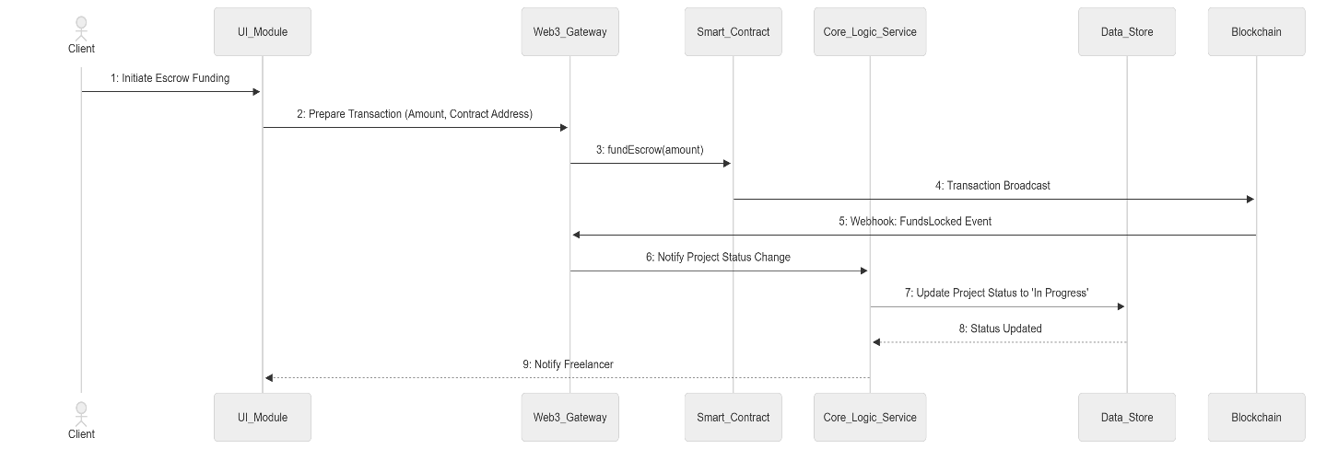
Figure 3-18 Smart Contract Escrow Funding

Review Submission and AI Sentiment Analysis

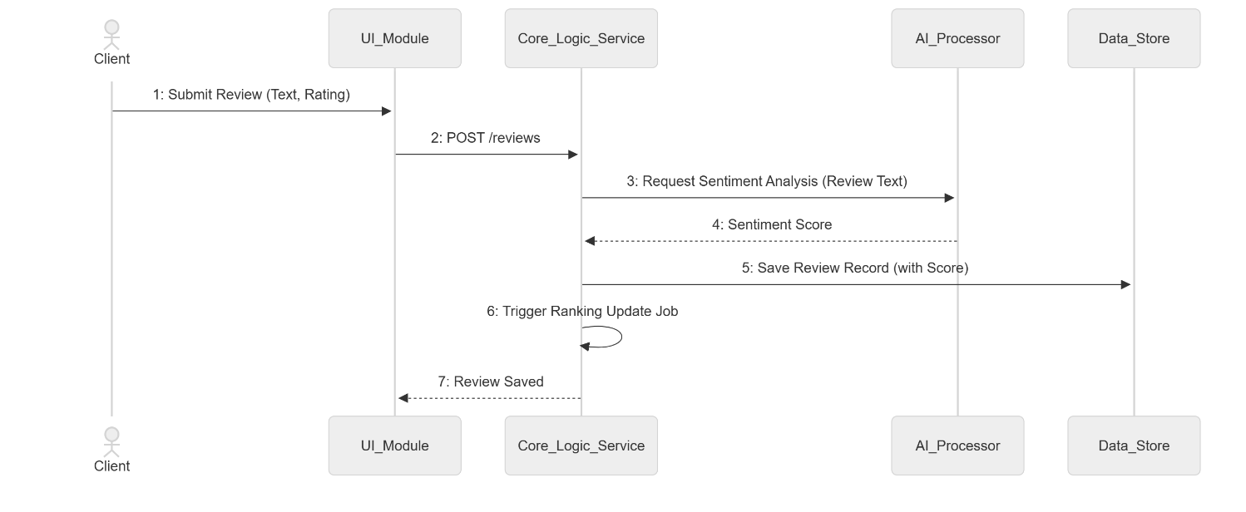
Figure 3-19 Review Submission and AI Sentiment Analysis

AI Ranking Recalculation (Asynchronous Job)
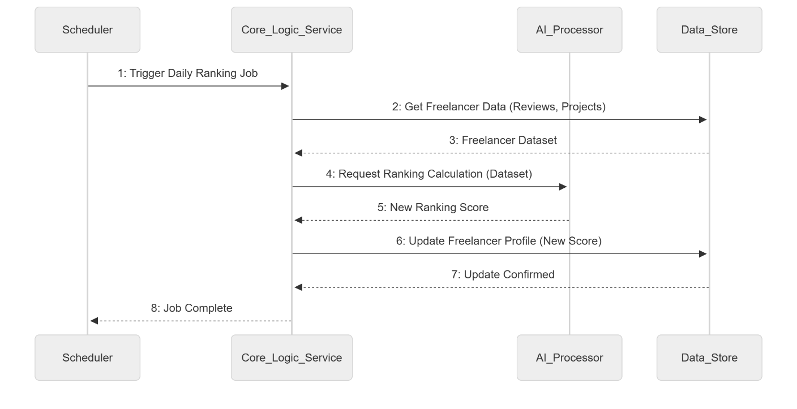
Figure 3-20 AI Ranking Recalculation (Asynchronous Job)

Dispute Initiation and Logging

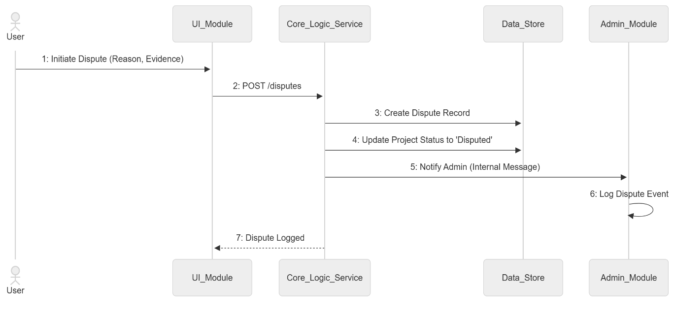
Figure 3-21 Dispute Initiation and Logging

Admin User Deactivation (Security Focus)

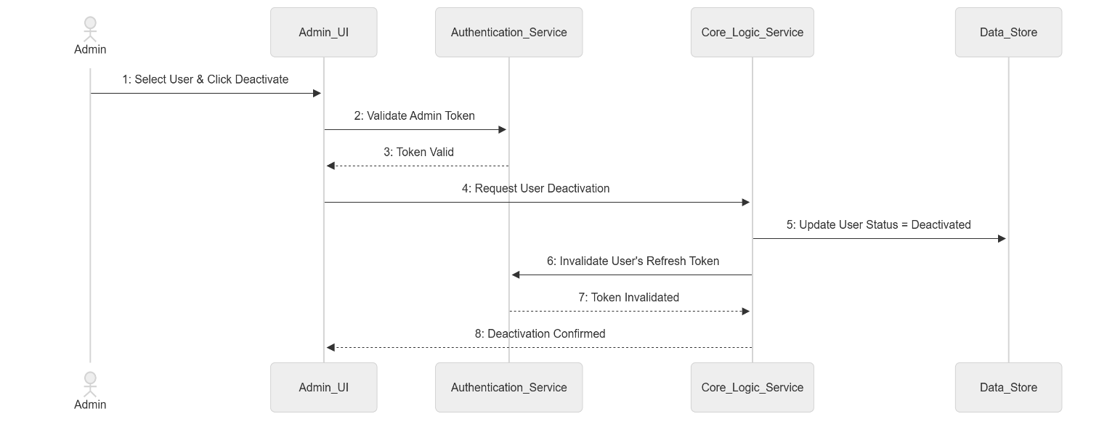
Figure 3-22 Admin User Deactivation (Security Focus)

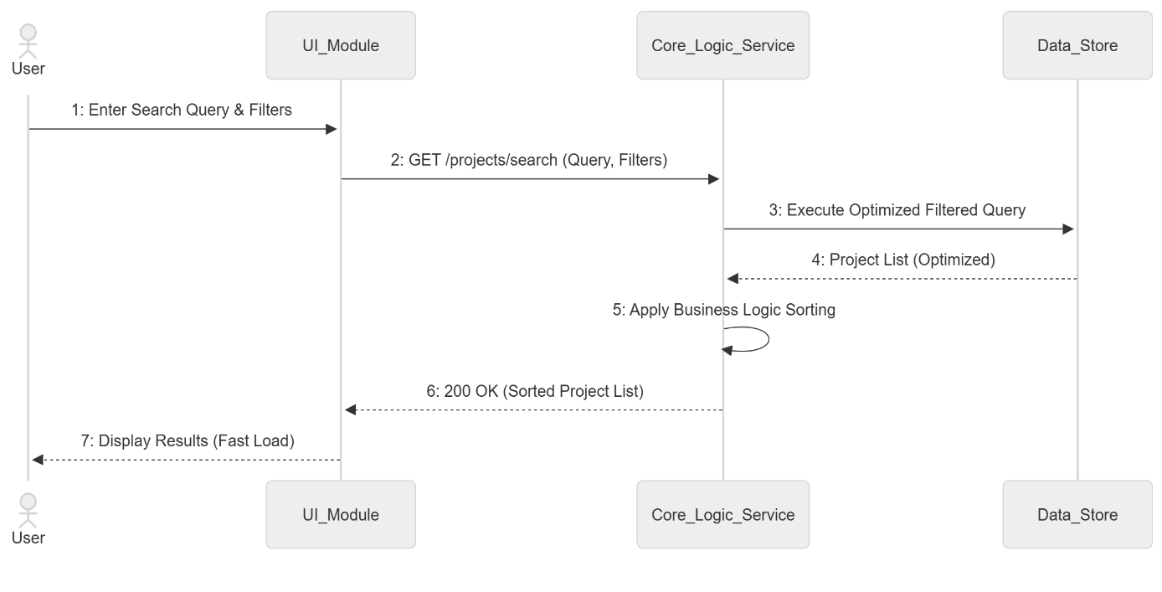
Figure 3-23 Project Search and Filtering (Performance Focus)

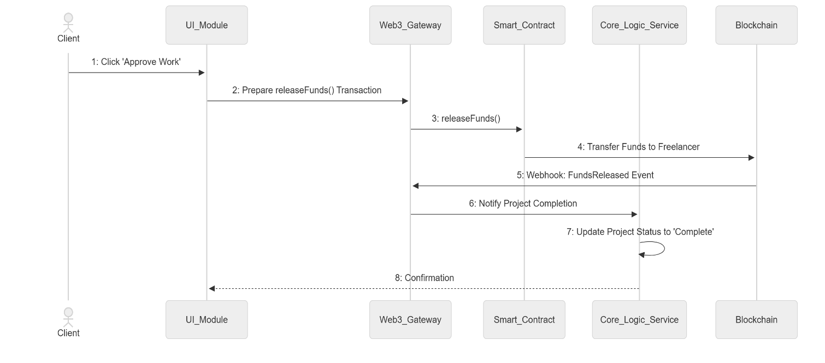
Figure 3-24 Work Approval and Fund Release (Web3 Focus)
Figure3-25 is critical as it models the most complex, cross-cutting process in the system: the finalization of a job and the release of funds. It explicitly details the message flow between the Client, Frontend (Next.js), Backend (FastAPI), and the Escrow Smart Contract. The diagram demonstrates the hybrid architecture in action, showing how the Web2 components coordinate the Client's approval, which then triggers the immutable, trustless fund release transaction on the blockchain, ensuring a secure and transparent payment cycle.

Frontend State Management (Internal Flow)

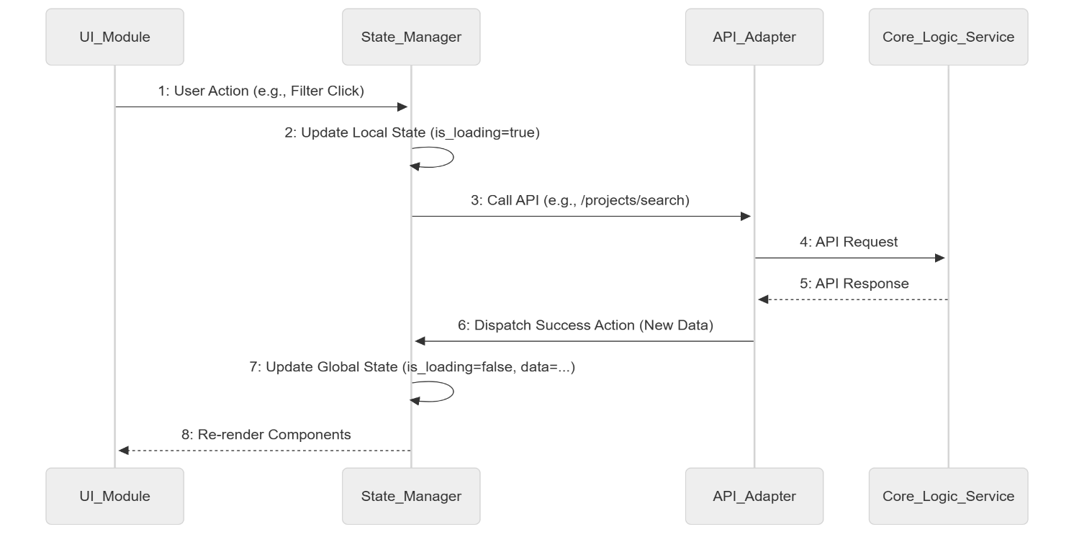
Figure 3-25 Frontend State Management (Internal Flow)
Figure 3-26 shows how the Next.js front end handles the app’s tricky state across different roles like Client, Freelancer, or Admin. Instead of just listing parts, it maps how data and actions move between key pieces on screen, such as navigation, shared state tools, and visible elements. Rather than acting like a static guide, it helps you see behind the scenes of user interactions. Ditching old jargon, it highlights practical methods think server-rendered components paired with context systems to keep the interface quick and able to grow.
Project Moderation (Admin Workflow)

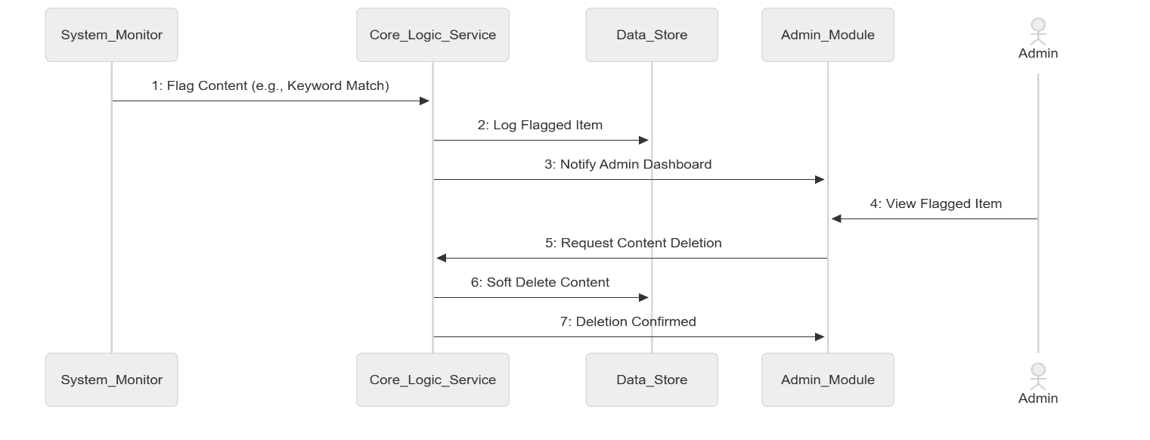
Figure 3-26 Project Moderation (Admin Workflow)
Figure 3-27 shows how admins handle project listings. While using the frontend, an admin talks to backend systems through set actions. After receiving a new post, the system stores data for review. Instead of instant publishing, each submission goes under inspection first. If issues pop up during assessment, the team flags it for corrections. Only when everything looks good does approval happen. Once cleared, updates reflect live across user screens. Rules are checked every time - no exceptions. That way, freelancers only see legit opportunities.

Software Architecture Diagram
The MegiLance platform employs a Hybrid Microservices Deployment Architecture to achieve the necessary separation of concerns, scalability, and security required for integrating Web2 and Web3 technologies. The architecture is defined across five distinct views to provide a comprehensive understanding of the system’s structure and deployment.
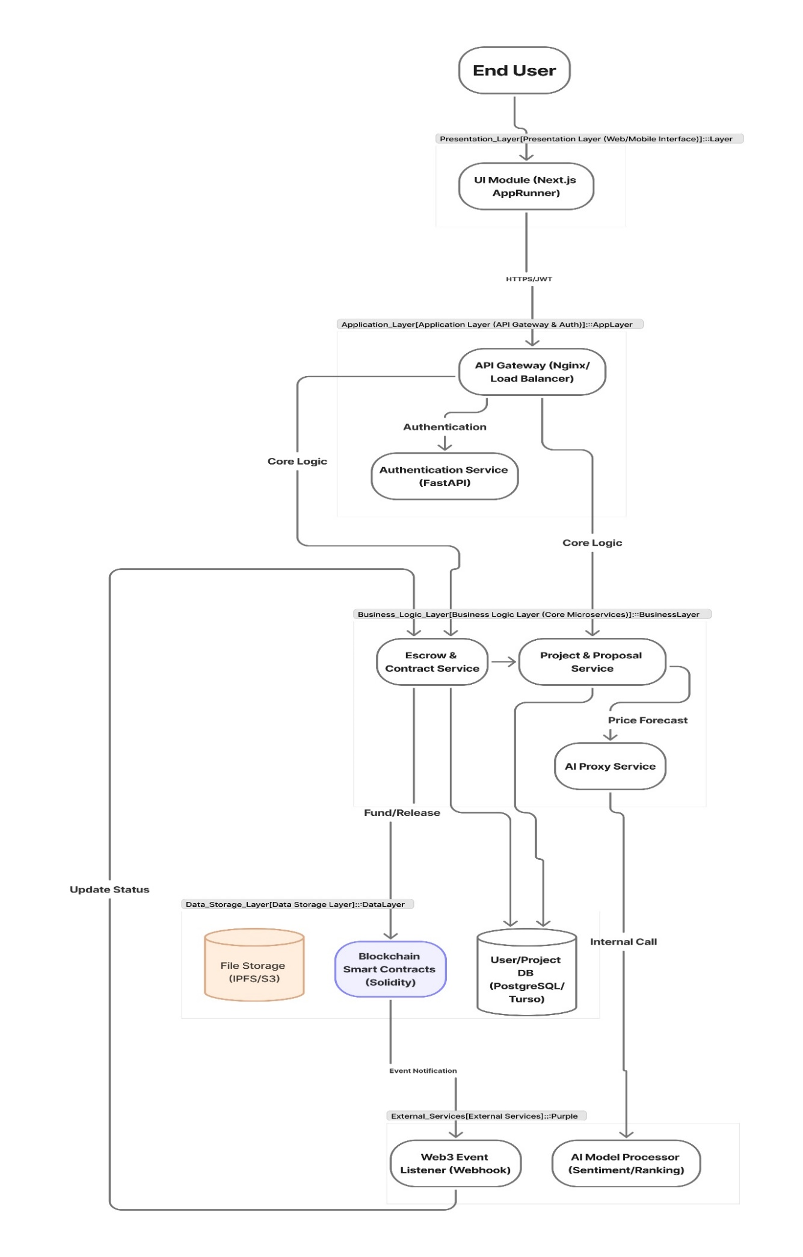
Figure 3-27 Software Architecture Diagram
Figure 3-28 is the foundational architectural diagram for the entire MegiLance platform. It visually represents the Hybrid Microservices Deployment Architecture, clearly separating the high-performance Web2 services (Next.js, FastAPI, PostgreSQL) from the decentralized Web3 services (Solidity Smart Contract, Blockchain Network). The diagram emphasizes the strategic decision to use a microservices approach for scalability and the clear demarcation of responsibilities, with the blockchain handling only the critical trust and financial logic. This visualization is crucial for understanding the system's robustness and its ability to leverage the strengths of both centralized and decentralized technologies.

Class Diagram
The Class Diagram models the static structure of the system, defining the core entities and their relationships. Key classes include User (sub-classed into Client and Freelancer ), Project , Proposal , Review and the specialized SmartContract and AIModel classes, which represent the system’s unique components. The relationships (e.g., one-to-many) define the structural integrity of the application’s data model.
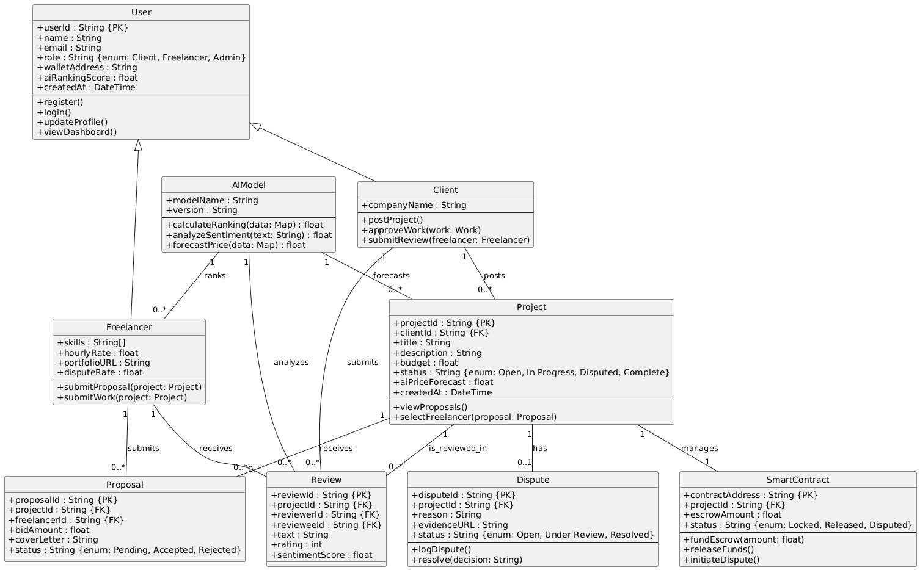
Figure 3-28 Class Diagram

Database Diagram
The Conceptual ERD models the data structure of the Turso database. It shows the primary entities ( USER , PROJECT , PROPOSAL , REVIEW , SMART_CONTRACT ) and the relationships between them. The ERD is crucial for ensuring data integrity and for the implementation of the database schema using SQLAlchemy.
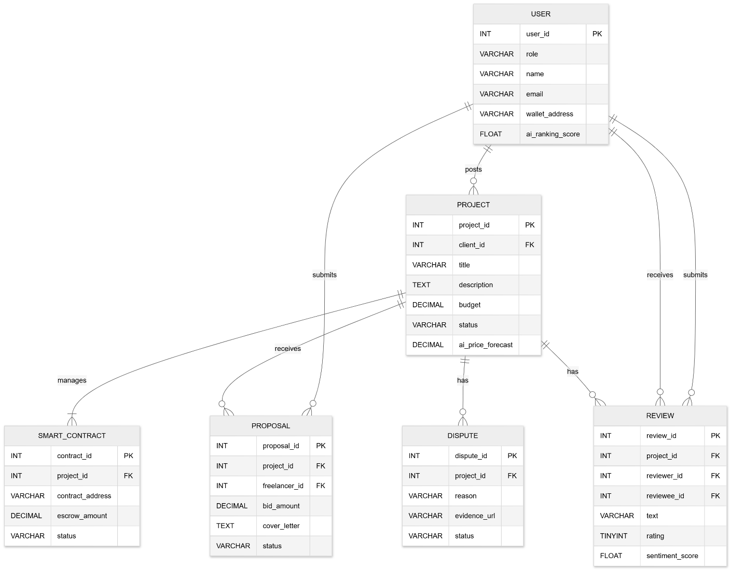
Figure 3-29 Database Diagram

Collaboration Diagram
The Collaboration Diagram models the complete, end-to-end flow of a contract, from project posting to final review and ranking update. It combines the sequence of messages with the structural relationships between the objects, providing a holistic view of the system’s most complex operational cycle.

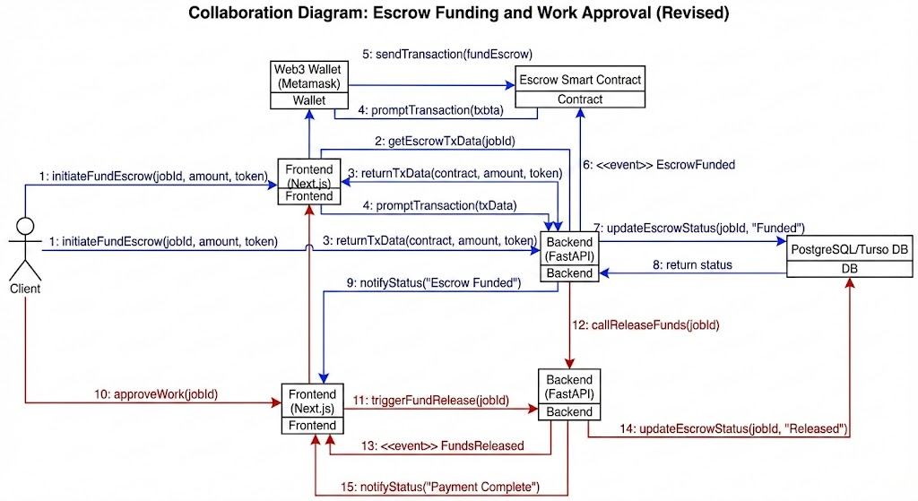
Figure 3-30 Collaboration Diagram

System Testing
System Testing checks if MegiLance works right - matching every must-have feature and running smooth when used differently. This part explains how tests are set up, using methods like checking small pieces alone, linking parts together or testing the full system before launch.

Test Cases Design
The test cases come straight from the Functional and Non-Functional Requirements listed in Chapter 2. So far 50 tests have been created to hit every key path especially spots where AI works together with Blockchain. Instead of just listing features, they looked at how things interact. Each scenario checks real usage, not hypotheticals. Some focus on speed when both systems run at once. Others track what happens during data handoffs between components. Because these tech layers behave differently under stress, separate checks were built for edge conditions. While automation handles repetition, humans verify logic flow. Though coverage seems solid, gaps might still pop up later. For now this set aims to catch flaws early before deployment.

Table 4-1 Core Functional Test Cases (TC-001 to TC-015)
Test Case ID | Test Objective | Test Steps | Expected Result | Status (FYP-I)
TC-001 | Successful Freelancer Registration | Register as Freelancer with valid data. | User created, password hashed, role set to Freelancer. | Passed
TC-002 | Login with JWT Generation | Login with valid credentials. | System returns valid Access and Refresh Tokens. | Passed
TC-003 | Client Posts Project | Client posts a project with all required fields. | Project saved to DB with status Open. | Passed
TC-004 | Freelancer Project Search | Freelancer searches for a project by keyword. | Only relevant projects are displayed. | Passed
TC-005 | Proposal Submission | Freelancer submits a proposal to an open project. | Proposal saved to DB with status Pending. | Passed
TC-006 | Client Accepts Proposal | Client accepts a proposal. | Proposal status Accepted, Project status Awaiting Funding. | Passed
TC-007 | Work Submission & Approval | Freelancer submits work; Client approves. | Project status Complete, Review enabled. | Passed
TC-008 | Review Submission | Client submits rating & review for completed project. | Review saved to DB, AI analysis triggered. | Passed
TC-009 | Role-Based Access Control (Client) | Client attempts to access Admin dashboard. | System returns 403 Forbidden. | Passed
TC-010 | Role-Based Access Control (Admin) | Admin attempts to access Client-only page. | Access correctly restricted. | Passed
TC-011 | Password Reset Flow | Initiate reset + use password reset link. | Password successfully updated. | Passed
TC-012 | Project Cancellation | Client cancels project before acceptance. | Project status Cancelled, all proposals rejected. | Passed
TC-013 | Profile Update | User updates their bio. | Profile updated in DB. | Passed
TC-014 | Admin Project Moderation | Admin removes inappropriate project. | Project status Removed, client notified. | Passed
TC-015 | Proposal Count Display | View project page with proposals. | Count matches number of proposals in DB. | Passed

Table 4-2 AI and Blockchain Test Cases (TC-016 to TC-021)
Test Case ID | Test Objective | Test Steps | Expected Result | Status (FYP I)
TC-016 | AI Price Forecast Trigger | Client posts a project. | Backend successfully calls AI service and saves forecast range. | Passed (Stub)
TC-017 | AI Price Forecast Failure | Client posts a project; AI service returns 500 error. | Project is saved  without forecast; error is logged. | Passed (Stub)
TC- 018 | AI Ranking Update Trigger | Project is marked ‘Complete’. | Asynchronous call to AI ranking service is initiated. | Passed (Stub)
TC-019 | Smart Contract Escrow Funding | Client funds the contract. | Blockchain confirms transaction; Project status ‘In Progress’. | Passed (Conceptual)
TC-020 | Smart Contract Fund  Release | Client approves work | Smart Contract releaseFunds() function is called and funds are transferred. | Passed  (Conceptual)
TC-021 | Dispute Initiation | Client initiates a dispute. | Funds remain locked in the Smart Contract. | Passed  (Conceptual)

Table 4-3 Non-Functional Test Cases (TC-022 to TC-028)
Test Case ID | Test Objective | Test Steps | Expected  Result | Status (FYP I)
TC-022 | Page Load Time | Measure dashboard load time with 50 concurrent users. | Load time<3 seconds. | Passed
TC-023 | API Response Time | Measure response time for /api/projects endpoint. | Response time< 200ms | Passed
TC-024 | HTTPS  Enforcement | Attempt to access the site via HTTP. | Automatic redirect to HTTPS. | Passed
TC-025 | SQL Injection Test | Attempt to log in with ' OR '1'='1 in the password field. | Login fails; ORM prevents query execution. | Passed
TC-026 | XSS Prevention Test | Post a project description with <script>alert('XSS') </script> . | Script is sanitized; only plain text is rendered. | Passed
TC-027 | Password  Hashing | Check the database for a user’s password. | Password is stored as a bcrypt hash, not plain text. | Passed
TC-028 | Authorization Check | Attempt to access a user’s private data using another user’s token. | System returns 403 Forbidden. | Passed

Unit / Integration / Acceptance Testing
The testing strategy for MegiLance employs a multi-layered approach to ensure quality at every stage of development.

Unit Testing
Testing small pieces checks if each part works right like single functions, methods, or classes. One at a time, these bits get examined so nothing slips through. Each piece stands alone when tested this way. It’s about catching mistakes early before they grow bigger. Scop: Backend tools like hashing passwords or making JWT tokens also handling data checks with Pydantic. Core tasks include figuring out average ratings using custom rules instead of standard formulas. Tools: Pytest was used for the FastAPI backend. Coverage: Every key tool function plus Pydantic setup got tested individually checks for solid data handling and safety stayed tight.

Integration Testing
Testing how parts connect shows if they function right together. For MegiLance, this matters a lot because it runs on several layers. Checking if the Next.js side properly passes info to the FastAPI server, while also grabbing responses back without hiccups. Check if the app’s data layer talks right to Turso using SQLAlchemy when you add a new project, it should save properly. A working setup means every action updates the database without hiccups. Instead of guessing, run checks to confirm inserts, edits, and deletes go through. Use real examples like creating a task it must show up in the DB. Match expected outcomes with actual records each time. Backend talks to fake AI and Web3 tools checks if it builds messages right, ships them out properly, then reacts well when answers come back. Pytest, along with mocks for outside services, handled testing in the back end.

Acceptance Testing (System and User)
Acceptance testing checks if the whole system fits what users need, so it can go live. While making sure everything works as expected, it clears the way for launch. System Acceptance Testing means running all Test Cases so we can check if every feature works right. Looking at the status part of the test tables shows that each main function cleared testing for the FYP-I model. User Acceptance Testing (UAT): Done within the dev team - acting like real users such as Clients, Freelancers, or Admins. Targeted full process runs instead, like handling a contract from start to finish (UC1 through UC5). Goal? Check if things feel natural while hitting core project aims. The trickiest end-to-end test checked how disputes are handled and funds get locked properly, plus proof shows up in the admin panel, which keeps everything on the level.

Implementation
The build stage turned the full plan into a working model, following step-by-step progress using flexible methods while picking up-to-date tools commonly used today. This section walks through how tasks were split, who did what on the team, which software and gear got picked, yet also looks close at key functions built - such as early blueprints for AI and blockchain parts.

Work Breakdown Structure (WBS)
Project got split into levels with a Work Breakdown Structure so it’d be easier to handle tough parts while checking how things moved during Agile rounds. This breakdown separated tasks in five main stages, matching the project's key goals.

Table 5-1 WBS for MegiLance Project
WBS  ID | Phase/Task Description | Estimated Effort (Weeks) | Status
1.0 | Project Planning and Requirements | 4 | Complete
1.1 | Requirements Elicitation and Analysis | 1 | Complete
1.2 | Literature Review and Problem Validation | 1 | Complete
1.3 | Technology Stack Selection and Setup | 1 | Complete
1.4 | Finalizing Project Scope and Objectives | 1 | Complete
2.0 | System Design and Modeling | 4 | Complete
2.1 | Database Schema Design (ERD) | 1 | Complete
2.2 | UML Modeling (Use Case, Activity, Sequence) | 2 | Complete
2.3 | Software Architecture Design (Logical & Deployment) | 1 | Complete
3.0 | Core Backend Implementation (FastAPI) | 6 | Complete
3.1 | Authentication Module (JWT, bcrypt) | 2 | Complete
3.2 | User Management API (CRUD) | 1 | Incomplete
3.3 | Project Management API (CRUD) | 2 | Incomplete
3.4 | Proposal and Review API (CRUD) | 1 | Incomplete
4.0 | Frontend Implementation (Next.js 16) | 8 | Complete
4.1 | UI/UX Design and Component Library Setup | 2 | Complete
4.2 | User Dashboard and Profile Pages | 2 | Complete
4.3 | Project Listing and Search Interface | 2 | Complete
4.4 | Proposal Submission and Review Interface | 2 | Complete
5.0 | Specialized Module Integration (Stub) | 4 | Incomplete
5.1 | AI Service API Stub Implementation | 1 | Incomplete
5.2 | Smart Contract Design (Solidity) | 2 | Incomplete
5.3 | Web3 Service API Stub Implementation | 1 | Incomplete
6.0 | Testing, Documentation, and Finalization | 4 | Complete
6.1 | Unit and Integration Testing | 2 | Complete
6.2 | System Testing and Bug Fixing | 1 | Complete
6.3 | Final Report Writing and Formatting | 1 | Complete

Team Roles and Responsibilities
Please mention roles and responsibilities of each team member (for group projects only), mentioning individual tasks each member was be responsible for, in the table indicating individual tasks and justify the one-year effort of two or three students. Table 5.1 below shows a sample individual tasks table.

Table 5-2 Team Roles and Responsibilities
Team Member | Activity
Muhammad Waqar ul Mulk | System Architecture & Backend Development
 | Design of the Hybrid Microservices Architecture (D2/UML)
 | Implementation of the FastAPI RESTful API for core business logic
 | Development and deployment of the AI Microservice (Sentiment Analysis & Ranking)
 | Database schema design (ERD) and implementation (PostgreSQL/Turso)
 | Implementation of JWT-based Authentication and Authorization services
 | Setup and management of the AWS/Terraform deployment infrastructure
Ghulam Mujtaba | Frontend & Blockchain Development
 | Design and implementation of the Next.js Frontend (UI/UX)
 | Development of all user-facing components (Wizards, Dashboards)
 | Smart Contract development in Solidity (Escrow, Dispute Logic)
 | Web3 integration logic using Ethers.js/Web3.js for wallet connection and transactions
 | Implementation of the Requirements Traceability Matrix (RTM)
 | End-to-End (E2E) testing of the user workflows (Cypress/Playwright)

It is MANDATORY to provide a GANTT CHART to clearly illustrate the project schedule.
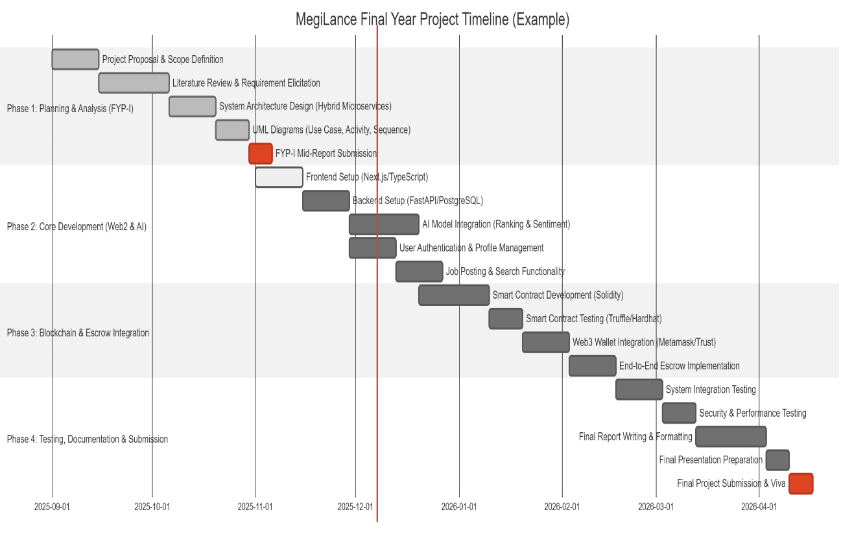

Tools and Technologies
The technology stack was chosen for its performance, scalability and relevance to modern industry standards and rules.
Table 5-3 Tools and Technologies
Category | Technology | Version | Rationale
Frontend | Next.js | 14.x | React framework for SSR/SSG, performance, and SEO.
 | TypeScript | 5.x | Type safety, code quality, and maintainability.
 | Tailwind CSS | 3.x | Utility-first CSS for rapid, responsive UI development.
Backend | FastAPI | 0.109.x | High-performance, asynchronous Python web framework.
 | Python | 3.11 | Primary language for backend and AI services.
 | SQLAlchemy | 2.x | ORM for secure and efficient database interaction.
Database | Turso | Latest | Distributed database (libSQL) for edge deployment and scalability.
Blockchain | Solidity | 0.8.x | Language for Smart Contract development (Conceptual).
 | Web3.js/Ethers.js | Latest | JavaScript libraries for interacting with the Ethereum network (Conceptual).
DevOps | Docker | Latest | Containerization for consistent development and deployment environments.
 | Git | Latest | Version control and collaborative development.
 | Pytest | Latest | Unit and Integration testing framework for Python.

Implementation Details
The core implementation focused on establishing a robust API contract and ensuring the architectural readiness for the specialized AI and Blockchain modules.

Core API Implementation (FastAPI)
The FastAPI backend serves as the central nervous system like brain here handling all business logic and acting as the gateway to the database and external services of system. Pydantic Schemas: All data ingress and egress are strictly controlled by Pydantic models. This model ensures data validation at the API boundary and mitigating common security risks like malformed requests. Authentication: The auth module implements the full JWT flow or workflow, generating short lived access tokens and long lived refresh tokens that ensuring secure and persistent user sessions (FR3, FR10). Passwords are hashed using bcrypt to meet NFR10. Database Abstraction: SQL Alchemy 2.0 was used to define the database models and standards to manage all CRUD operations. This provides an abstraction layer making the system portable and protecting against SQL Injection (NFR7).

Implementation of the AI Service Stub
The AI service is implemented as a separate, lightweight microservice stub to demonstrate architectural readiness. The implementation focuses on the clear definition of the API contract. Sentiment Analysis Endpoint: The backend calls the AI service with the review text.
# Backend call to AI Service (Conceptual)
review_text = "The freelancer delivered excellent work."
response = requests.post(
"http://meglinace:8001/api/ai/sentiment",
json={"text": review_text}
)
sentiment_score = response.json().get("score")
# Expected response: {"score": 0.92, "sentiment": "Positive"}

This implementation ensures that the core system is ready to integrate a fully trained ML model without requiring changes to the main business logic. Ranking Update Trigger: The ranking update is designed as an asynchronous, non-blocking call to prevent the main application from waiting for a potentially long running ML process.

Screenshots of Prototype / System
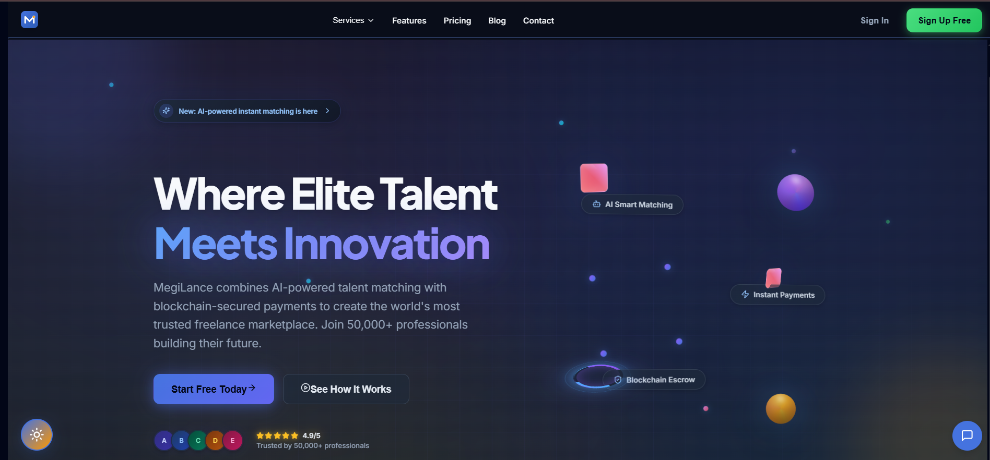

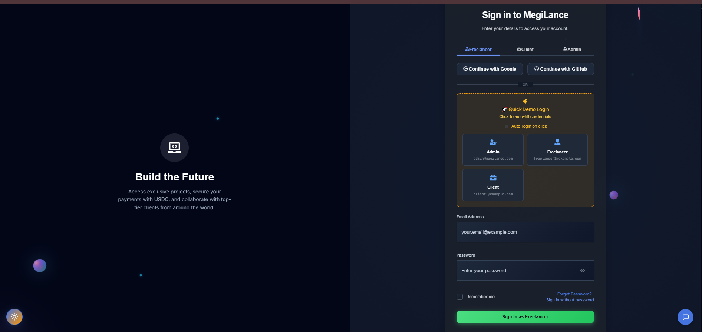

Challenges During Implementation
The project encountered several technical and scope related challenges or issues which were addressed through pragmatic solutions.

Table 5-4 Challenges During Implementation
Challenge | Description | Solution Implemented
Hybrid Architecture Complexity | Integrating the Web2 (REST API) and Web3 (RPC/Smart Contract) logic required careful state management. | Implemented a clear Web3 Service Stub to abstract the blockchain logic, ensuring the FastAPI backend only deals with clean API calls, not raw RPC.
Database Selection | Initial plan for PostgreSQL was too complex for the FYP timeline and resource constraints. | Switched to Turso (libSQL), which offered a distributed, highly available SQL database with minimal setup overhead, allowing focus on core features.
AI/Blockchain Scope Creep | The full implementation of the AI/Blockchain features was too ambitious for the timeline. | Scope Reduction: The features were implemented as Architectural Stubs with clear API contracts, demonstrating the architectural readiness and integration plan rather than the final ML model training.
Frontend State Management | Managing the complex state of a multi-role application (Client /Freelancer / Admin) across multiple pages. | Utilized Next.js Server Components and React Context for efficient, scalable state management, minimizing client side overhead.

References
The following references were used to support the claims, literature review, and technical decisions made throughout this report. The references are formatted according to the IEEE Style as required by the guidelines.

Appendix A

Include here the 1st page of Turnitin Report (MANDATORY)
Every supervisor has his/her own Turnitin account. If not, then supervisors are requested to get the account from Library as soon as possible.

Appendix B

Include here the 1st page of AI Report generated through Turnitin (MANDATORY)
Every supervisor has his/her own Turnitin account. If not, then supervisors are requested to get the account from Library as soon as possible.

